CHRISTMAS PUNCH  COOK TIME: 10 min  SOURCE:  #holiday #beverage #refreshing | 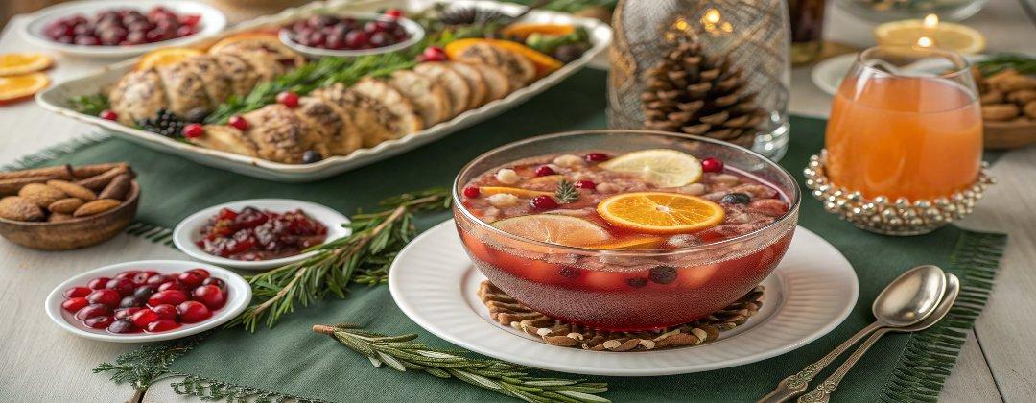

INGREDIENTS  - 6 cups (1440ml) cranberry juice (1.44 L)  - 2 cups (480ml) pomegranate juice (480 ml)  - 2 cups (480ml) orange juice (480 ml)  - 1 L ginger ale  - 2 cups (480ml) vodka (rum works as well)  - Orange slices (for garnish)  - Fresh cranberries (for garnish) | PREP  COOK  1. Chill all of the ingredients well.  2. Combine the juices, ginger ale, and vodka in a large punch bowl. Garnish with orange slices and fresh cranberries. Serve in glasses filled with ice.  PLATING

