GREEK SALMON SALAD RECIPE  COOK TIME: 12 min  SOURCE:  #healthy #quick #light | 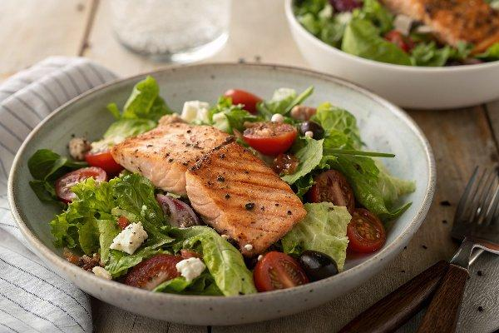

INGREDIENTS  - 1 lb Salmon fillet, (cut into 4 equal pieces)  - Kosher salt and black pepper  - 11/2 tsp dried oregano  - 8 oz hearts of Romaine lettuce, (chopped)  - 10 oz cherry or grape tomatoes  - 1 bell pepper (any color, cored and sliced into rounds)  - 1 English cucumber (sliced into rounds)  - 2 shallots (sliced)  - pitted Kalamata olives (to your liking)  - Quality Greek feta blocks (to your liking)  - 1/2 cup Extra virgin olive oil  - 2 large lemons  - 2 garlic cloves, (roughly chopped)  - 20 to 30 fresh mint leaves, (no stems (about 7 g or so)  - 1 tsp dried oregano  - 1/2 tsp sweet paprika  - 1 lb salmon fillet (cut into 4 equal pieces)  - Kosher salt and black pepper  - Dried oregano (a generous pinch 1 1/2 tsp or more to your liking) | PREP  COOK  1. Preheat the oven to 425°F (220°C) and position a rack in the middle.  2. Season the salmon. Pat the salmon dry on both sides and season with kosher salt, pepper, and dried oregano. Arrange on a lightly oiled sheet pan and brush the top of the salmon with extra virgin olive oil.  3. Bake the salmon in the heated oven for 8 to 12 minutes until it's done and flakes easily (see cook's tip #1 below). Meanwhile, work on the salad and the vinaigrette.  4. Prepare the salad. In a large salad bowl, add the lettuce, tomatoes, bell peppers, cucumbers, shallots, and Kalamata olives (don't add the feta yet)  5. Prepare the vinaigrette. In the small bowl of a food processor fitted with a blade, add olive oil, lemon juice, garlic, fresh mint, oregano, and paprika. Add a pinch of Kosher salt and black pepper. Blend until well-combined.  6. Pour about 1/2 of the vinaigrette over the salad. Toss to combine. Now add the feta cheese blocks on top. (Hold the remaining vinaigrette to dress the salmon later).  7. Build your salmon salad bowls. Transfer the salad to 4 serving bowls, top each with 1 fillet of salmon. Drizzle the remaining vinaigrette on top of the salmon. Enjoy!  PLATING

