SANSHOKU BENTO  COOK TIME: 5 min  SOURCE:  #bento #comfort-food #rice | 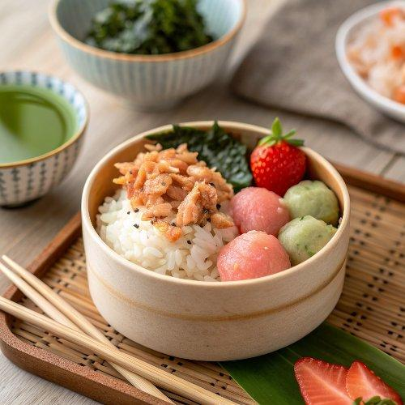

INGREDIENTS  - 1 serving cooked Japanese short-grain rice  - soboro don  - Homemade Japanese Salted Salmon (shredded)  - shredded nori seaweed (kizami nori)  - strawberries | PREP  COOK  1. Pack rice in ⅔ of bento box and put salmon flakes, scramble egg, and ground chicken on top of the rice. Sprinkle shredded nori.  2. Add strawberries in ⅓ of the bento.  3. Cool down completely before closing the bento box.  PLATING

