1 BOWL VEGAN COCONUT CAKE  COOK TIME: 35 min  SOURCE:  #cake #coconut #baking | 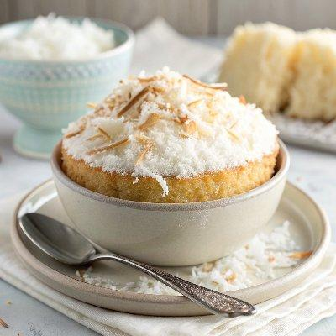

INGREDIENTS  - 2 1/2 cups all purpose flour  - 2 tbsp cornstarch  - 1 tbsp baking powder  - 1/2 tsp salt  - 1 1/2 cups granulated sugar  - 3/4 cup neutral flavored oil or melted vegan butter  - 1 1/2 cups non-dairy milk (I used coconut milk, not from a can)  - 2 tsp apple cider vinegar  - 2 tsp pure vanilla extract  - 1 tsp coconut extract  - 8 oz vegan cream cheese  - 1/2 cup vegan butter, slightly softened  - 3-4 cups (960ml) powdered sugar  - 1 tsp pure vanilla extract  - 1 tsp coconut extract  - 1 cup (240ml) shredded fine coconut, optional for topping cake | PREP  COOK  1. Make the cake  2. Preheat the oven to 350°F (175°C) and grease two 8-inch (20cm) cake pans. I also like to place a circle of parchment paper on the bottom of each pan for easy removal.  3. In a large bowl, add the flour, cornstarch, baking powder, salt and sugar. Whisk well to combine.  4. To the bowl with the dry ingredients, pour in the oil, non-dairy milk, apple cider vinegar, vanilla and coconut extract. Mix with a large spoon until just combined, but be careful not to over mix the batter or your cake won't be soft and fluffy.  5. Pour into prepared pans and bake for 30-35 minutes, until a toothpick inserted in the middle comes out clean.  6. Let the cakes cool in the pan for 10 minutes, then carefully remove them and place on a cooling rack. Allow the cakes to cool completely before frosting; you can move them to the refrigerator to speed this up.  7. Make the frosting  8. To a large bowl (you can simply wipe out the bowl you used for the cake), add vegan cream cheese, slightly softened vegan butter (not too soft, or your frosting will be melty), 3 cups (720ml) of powdered sugar, vanilla and coconut extract.  9. With a hand mixer, or stand mixer, mix starting on low, then increase to high until all ingredients are combined and smooth. If the frosting seems too runny, add another cup of powdered sugar. If it still is a bit runny, you can stick it in the refrigerator for 30 minutes or so until it firms up a bit.  1  0. Frost the cake as desired, then sprinkle with shredded coconut and serve. Enjoy!  PLATING

