JACKET POTATO BOARD  COOK TIME: 1h  SOURCE:  #comfort-food #quick #healthy | 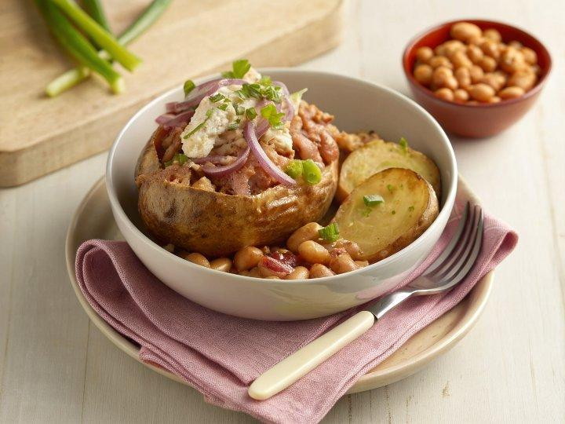

INGREDIENTS  - 8 maris piper potatoes  - 2 tsp olive oil  - 50 g canned tuna  - 1/4 celery stick  - 1 tbsp mayonnaise  - 1/4 red onion finely chopped  - pinch of smoked paprika  - 50-100 g baked beans  - a dash each of Tabasco or Worcestershire sauce (optional)  - 30 g grated mature cheddar  - 1 small cooked chicken breast  - 2 tsp medium curry powder  - 1 tsp mango chutney plus a little extra to serve  - 2 tbsp mayonnaise  - 1 tbsp yogurt  - 1/2 tsp turmeric  - 1/2 red onion finely chopped  - 50 g mature grated cheddar  - 1 1/2 mayonnaise  - 1 spring onion finely chopped | PREP  COOK  1. Heat the oven to 200C/180C fan/gas  4. Choose the smaller potatoes from the pack and tip onto a baking tray, rub with the oil and season to coat. Bake for 50 mins–1 hr until tender and the skin is crisp.  2. Mix all the ingredients for each filling in separate bowls and season.  3. Cut crosses into the jackets and arrange on a serving board. Use each of the fillings to fill two potatoes each and arrange side by side. Add a little more mango chutney to the coronation chicken.  PLATING

