CHOCOLATE SHORTBEAD COOKIES  COOK TIME: 16 min  SOURCE:  #chocolate #cookies #baking | 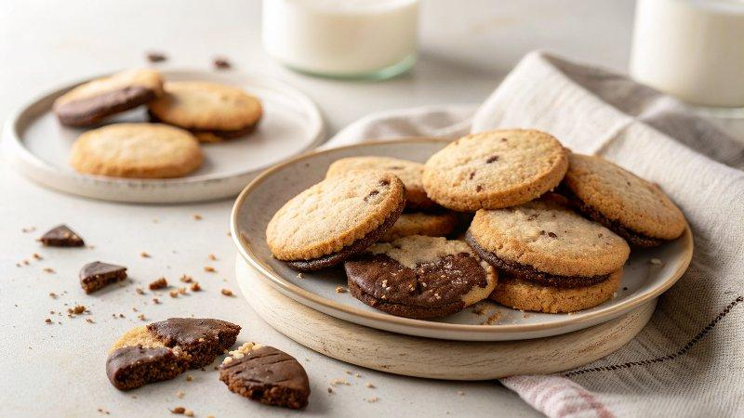

INGREDIENTS  - 1 3/4 cups (248 g) all-purpose flour ((scoop and level to measure))  - 6 Tbsp (36 g) unsweetened cocoa powder (or Dutch process cocoa (sift if clumpy))  - 1/4 tsp salt  - 1 cup (226 g) unsalted butter, (at cool room temperature)  - 1 1/4 cups (150 g) powdered sugar  - 1 1/2 tsp vanilla extract  - 10 oz. semi-sweet chocolate, (finely chopped, melted*) | PREP  COOK  1. In a mixing bowl whisk together flour, cocoa powder, and salt.  2. In the bowl of an electric stand mixer cream together butter and powdered sugar on low speed until combined. Increase to medium speed and beat until light and fluffy, about 2 minutes.  3. Scrape down bowl then blend in vanilla extract.  4. Add flour mixture and blend on fairly low speed until it comes together in clumps (it will look sandy at first) then increase speed slightly and mix until dough comes together.  5. Knead dough a few times by hand then divide into two equal portions.  6. Compress and roll each portion into a 5 1/2-inch (5cm) log. Wrap in parchment paper or plastic wrap and chill 1 hour.  7. During last 15 minutes of chilling preheat oven to 350 degrees. Line two 18 by 13-inch (33cm) baking sheets with parchment paper.  8. Remove one log of dough from fridge and cut into 1/3-inch (8cm) thick slices. Align on baking sheet spacing 1 1/2-inch (5cm) apart.  9. Bake in center of preheated oven until cookies are set, about 11 to 13 minutes.  1  0. Cool on pan 10 minutes then transfer to a wire rack, leave parchment paper on pans.  1  1. Once cool, working with one cookie at a time dip half into melted chocolate, shake and let excess chocolate run back into bowl (can scrape bottom of cookie along edge of bowl to remove some chocolate so it's not too thick of a layer). Transfer to cookie sheet lined with parchment and let chocolate set.  1  2. If desired you can finish with sprinkles but add these shortly after dipping in chocolate before it begins to set an harden. If you used tempered chocolate to dip cookies let the chocolate set at room temperature if you used untempered chocolate let the chocolate coated cookies set in the fridge.  PLATING

