NEXT LEVEL VEG CHILLI  COOK TIME: 50 min  SOURCE:  #comfort-food #spicy #hearty | 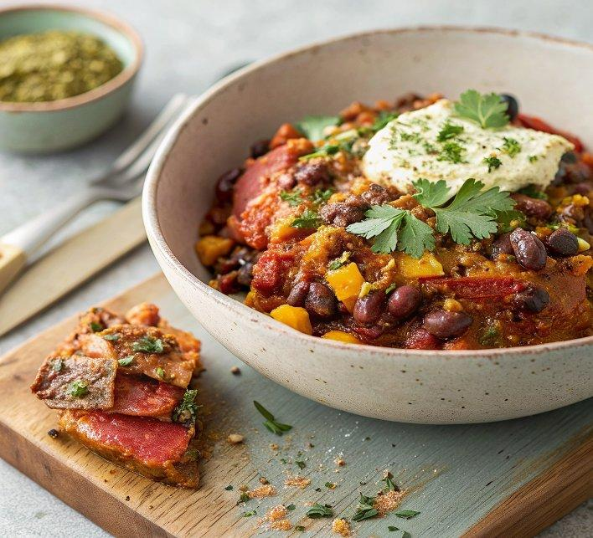

INGREDIENTS  - 2 tsp black peppercorns  - 2 tbsp cumin seeds  - 2 tbsp coriander seeds  - 2 tsp smoked paprika  - 2 tsp dried oregano  - 2 large or 3 small sweet potatoes peeled and cut into roughly 4cm (2-inch) chunks (no need to peel)  - 3 tbsp vegetable oil  - 2 onions finely chopped  - 6 garlic cloves finely chopped  - 1-2 tsp chipotle paste to taste  - 1 tbsp smooth peanut butter  - 2 tbsp apple cider vinegar  - 2 x 400 g cans chopped tomatoes  - 1 vegetable stock pot or cube  - 2 bay leaves  - small cinnamon stick  - 10 g dark chocolate (70-80% cocoa solids)  - 400 g can black beans drained but not rinsed  - 2 tbsp sliced jalapeños (optional)  - handful of chopped coriander and tortilla chips and guacamole or cooked rice, to serve (optional) | PREP  COOK  1. Heat the oven to 210C/190C fan/gas  7. Toast the peppercorns, cumin and coriander seeds in a small frying pan until lightly browned, then grind to a powder using a pestle and mortar or spice grinder. Mix with the paprika and oregano. Toss the sweet potato with 1 tbsp of the oil and a quarter of the spice mix, season with salt, then spread out on a baking tray. Roast for 25-30 mins, turning halfway, until golden and tender. Set aside.  2. Heat the remaining oil in a flameproof casserole dish over a medium heat. Fry the onions for 12-15 mins until soft and golden, then add the garlic and cook for another minute. Stir in the rest of the spice mix, the chipotle paste and peanut butter and cook for 2-3 mins until fragrant and thick.  3. Splash in the vinegar and cook for 1 min, then add the tomatoes. Stir and simmer for 10 mins until it’s a thick paste. Pour in 300ml (1.2 cups) boiling water and add the vegetable stock pot, stirring well to combine, then add the bay leaves, cinnamon stick, and some salt. Bring back to a simmer, reduce the heat and bubble for another 10 mins, stirring.  4. Grate in the dark chocolate and stir well. Add the roasted sweet potatoes, black beans and jalapeños, if using, and simmer for 5 mins. Will keep frozen for up to three months. Defrost before reheating. Bring the dish to the table, scatter over the coriander and serve with your favourite accompaniments.  PLATING

