CABBAGE AND BEET SALAD RECIPE  COOK TIME: 5 min  SOURCE:  #healthy #fresh #vegetable | 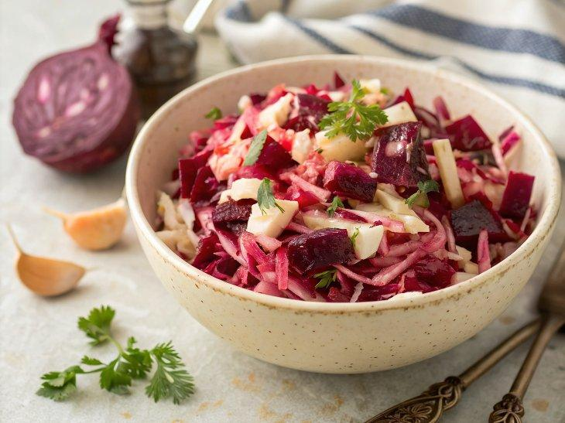

INGREDIENTS  - 2 medium heads of cabbage (5-6 lb total)  - 3 medium beets (1 lb)  - 3 large garlic cloves  - 2 cups (480ml) filtered water  - 1 1/4 cup oil (I used light olive oil)  - 1 cup (240ml) white vinegar  - 1 cup (240ml) of granulated sugar  - 2 Tbsp sea salt (best if it's not iodized) | PREP  COOK  1. In a medium sauce pan, combine all marinade ingredients: 2 cups (480ml) filtered water, 1 1/4 cup light olive oil, 1 cup (240ml) vinegar, 1 cup (240ml) sugar, and 2 Tbsp sea salt. Bring to a boil then remove from heat and cool to room temperature.  2. Finely shred cabbage (this is much easier with a mandolin and be sure to use safety gloves to protect your fingers) and transfer to your largest mixing bowl. Grate beets or cut them into matchsticks (we love this julienne slicer), then transfer to your mixing bowl. Finely dice garlic cloves and add them to the mixing bowl.  3. Pour cooled marinade over your chopped ingredients and stir to combine. Create a press to weigh down the cabbage enough to bring the marinade to the surface of the cabbage. We used a large dinner plate and a covered bowl with water for the weight. Refrigerate or let this stand in a cool room for 7-10 hours or overnight. We set it next to an AC vent.  4. Transfer salad to a large glass jug for easier storage in the fridge and keep refrigerated until ready to serve.This salad holds well in the refrigerator for about a week.  PLATING

