20-MINUTE CHICKPEA TACOS  COOK TIME: 15 min  SOURCE:  #quick #comfort-food #tacos | 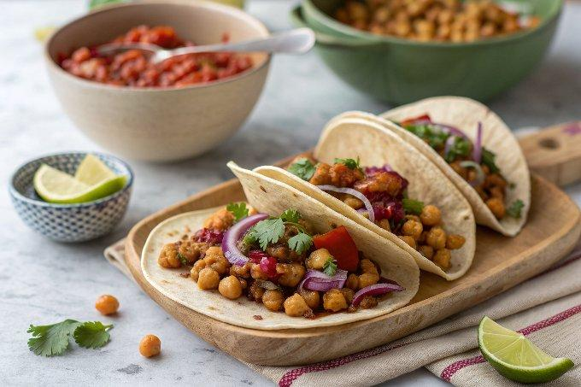

INGREDIENTS  - 1 (15-oz/425 g) can of chickpeas, (drained)  - 2 tsp extra virgin olive oil  - 3/4 tsp kosher salt  - 1/2 tsp dried oregano (Mexican oregano if you have it)  - 1/2 tsp smoked paprika  - 1/2 tsp garlic powder  - Pinch of cayenne pepper  - Squeeze of lime juice  - 1/2 cup (70 g) roasted cashews (or pistachios or walnuts)  - 2 1/2 cups (36 to 40 g) loosely packed cups of cilantro leaves and tender stems (no tough stems)*)  - 2 garlic cloves, (roughly chopped)  - 1 small jalapeño pepper, (roughly chopped**)  - 1 medium lemon (or 1 large lime, zested and juiced***)  - 1/4 tsp kosher salt, (plus more to taste)  - Freshly cracked black pepper to taste  - 1/3 cup (75 mL) extra virgin olive oil  - 6 corn tortillas  - Your favorite store-bought salsa****  - 1 large avocado, (diced) | PREP  COOK  1. If your nuts are raw, spread them out on a sheet pan and roast for 7 to 10 minutes at 350ºF, tossing halfway through.  2. Transfer the chickpeas to a clean dish towel or a layer of paper towels and gently pat dry as much as you can without smushing them. They need to be well-dried before cooking.  3. Heat a large nonstick frying pan over medium-high heat with the 2 teaspoons of oil and spread the oil out with a paper towel to evenly distribute it. Once hot, add the chickpeas and spread out in a single layer. Cook undisturbed for 2 to 3 minutes to allow some browning. Toss and cook for another 3 minutes, or until chickpeas are golden brown and blistered in spots.  4. Add salt and spices, and toss well to coat the chickpeas. Cook for 2 to 4 minutes to allow flavors to blend, then take off the heat and hit with a squeeze of lime juice.  5. Meanwhile, make the cilantro pesto. Add the nuts to a food processor and blitz until in very tiny pieces.Add the cilantro, garlic, jalapeño, lemon (or lime) zest, 2 tablespoons lemon (or lime) juice, ¼ teaspoon salt, and pepper to taste and blend until a paste forms. Scrape the paste towards the middle. Turn on the motor and stream in the olive oil until it comes together into a sauce. If needed, add 1 to 2 tablespoons of water to bring it all together, or add it for a thinner sauce. Taste, adding more lemon juice or salt as needed.  6. To char corn tortillas: If you have a gas stove, turn a burner to medium-low and use tongs to place the tortilla directly over the flame, 10 to 20 seconds per side until charred, in spots.Or, you can add each tortilla to a cast iron skillet over medium-high heat for 15 to 30 seconds per side. Stack and wrap charred tortillas in a dish towel to keep them warm.  7. To assemble the tacos, spoon some cilantro pesto into the center of each tortilla. Add a handful of the spiced chickpeas. Top with diced avocado and salsa.  PLATING

