NUTELLA STUFFED DEEP DISH CHOCOLATE CHIP SKILLET COOKIE (PIZOOKIE)  COOK TIME: 25 min  SOURCE:  #quick #comfort-food #chocolate | 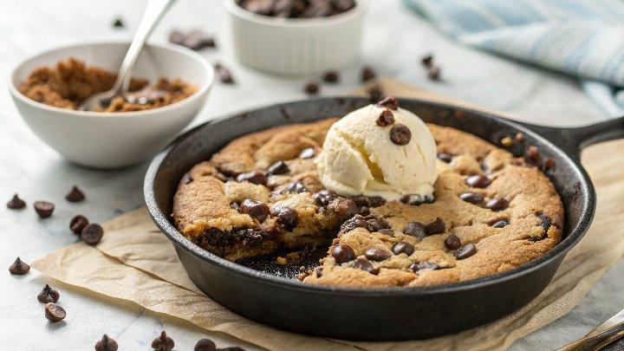

INGREDIENTS  - 1/2 cup butter (softened)  - 1/2 cup light brown sugar (lightly packed)  - 1/3 cup granulated sugar  - 2 tsp vanilla extract  - 1 egg (large)  - 1 cup (240ml) flour (all purpose or plain flour)  - 1/2 tsp baking soda  - 1/3 tsp salt  - 1/2 cup dark/semi-sweet chocolate chips  - 1/2 cup nutella (melted, or this Refined Sugar-Free Nutella Spread) | PREP  COOK  1. Preheat oven to 350° F | 175°C (350°F). Line a 9" cast iron skillet (or pie dish) with baking/parchment paper and set aside.  2. In a large bowl, whisk the butter, sugar and vanilla until light and creamy. Whisk in the egg until combined. Add the flour, baking soda and salt, and mix the dry ingredients into the wet until just combined. Fold in half of the chocolate chips and spoon 1/2 the cookie dough onto the prepared baking sheet.  3. Melt the Nutella in the microwave for 30 seconds until it becomes thinner in consistency.  4. Spread the Nutella over the cookie dough in the skillet evenly to 1-inch (3cm) of the edges. Top with remaining cookie dough, smoothing the layer with the back of a metal spoon (and your fingers if you need to). Sprinkle with remaining chocolate chips.  5. Bake in preheated oven for 25-30 minutes for a gooey cookie, or cover after 30 minutes with aluminium foil and bake for a further 10 minutes for a 'set' cookie. Cool for about 10 minutes before serving.  PLATING

