{LIGHT} ORANGE BEEF AND BROCCOLI  COOK TIME: 10 min  SOURCE:  #quick #comfort-food #stir-fry | 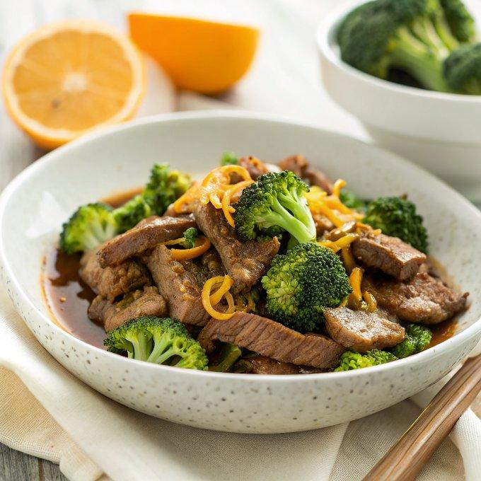

INGREDIENTS  - juice of 1 orange  - 1 tbsp fresh orange zest  - 2 tbsp low sodium soy sauce  - 1/4 cup beef broth  - 1/3 cup orange marmalade  - 2 tbsp cornstarch  - 1 tsp oil  - 1 lb. flank steak, very thinly sliced  - 2 cloves garlic, minced  - 1 head broccoli, washed and cut into bite-sized pieces | PREP  COOK  1. Mix the first 6 ingredients, whisking until the cornstarch is dissolved. Boil the broccoli for just a few minutes, until tender crisp. The broccoli will cook a little more once you add it in with the sauce, so make sure not to boil it for too long.  2. Heat the oil in a skillet over high heat. Add the steak and garlic, draining off extra fat after a few minutes. Flip the pieces until each piece is cooked through and the meat is browned.  3. Add the sauce to the pan and stir for 1 minute until the sauce starts to thicken. Remove from heat and stir in broccoli. Serve over rice and garnish with orange zest and/or scallions.  PLATING

