PLUM CAKE  COOK TIME: 55 min  SOURCE:  #baking #fruit #comfort-food | 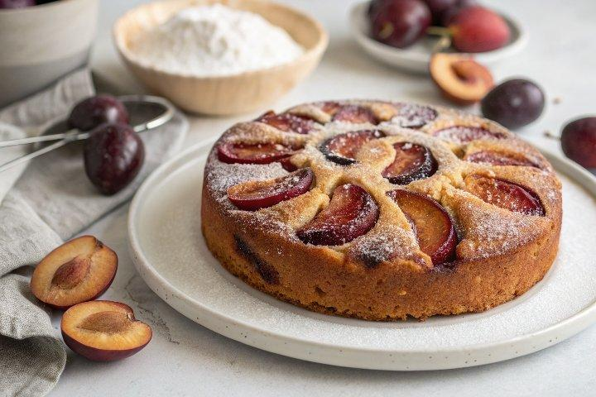

INGREDIENTS  - 1 1/2 cups all-purpose flour (180 g)  - 1 1/2 tsp baking powder  - 1/2 tsp ground cinnamon  - 1/2 tsp salt  - 1/2 cup unsalted butter softened (113 g)  - 3/4 cup granulated sugar (plus more for sprinkling (150 g)  - 2 large eggs  - 2 tsp vanilla extract  - 1/2 cup whole milk (room temperature (120 ml)  - 1 lb plums (pitted and quartered (4 to 6 plums) | PREP  COOK  1. Preheat the oven to 350°F (175°C). Lightly grease a 9-inch (23cm) springform baking with baking spray.  2. In a medium bowl, whisk together the flour, baking powder, cinnamon, and salt.  3. In a large mixing bowl or the bowl of a stand mixer fitted with the paddle attachment, beat the butter and sugar on medium speed until pale and fluffy, about 3 minutes. Add the eggs and vanilla and beat until very well combined. Scrape down the bowl.  4. With the mixer on low, gradually add the flour mixture in 3 parts, alternating with the milk between each addition of flour. Scrape down the bowl and mix one more time. Transfer the batter to the prepared baking pan and smooth the batter with a spatula.  5. Arrange the plum slices skin side up on top of the batter. Sprinkle generously with more sugar, if desired.  6. Bake for 55 minutes or until the top is golden brown and a toothpick inserted into the center comes out clean. Let the cake cool in the pan for 10 minutes. Run a knife around the edge of the pan before releasing the spring, and remove the outer ring. Let the cake cool completely before transferring to a serving plate or slicing.  PLATING

