VEGETABLE UDON STIR FRY (VEGGIE YAKI UDON)  COOK TIME: 5 min  SOURCE:  #quick #comfort-food #stir-fry | 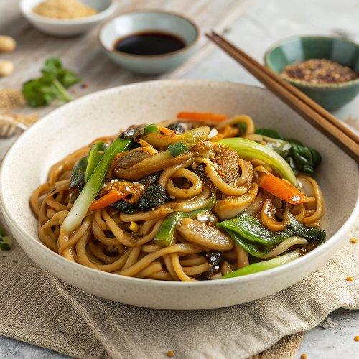

INGREDIENTS  - 12 oz Annie Chun’s Organic Udon Noodles  - 1 tbsp oyster sauce (or vegetarian oyster sauce)  - 1 tbsp soy sauce  - 1 tsp Shaoxing wine (or dry sherry)  - 1 tsp sugar  - 1 tsp sesame oil  - 2 tbsp peanut oil (or vegetable oil)  - 2 cloves garlic , minced  - 1/2 onion , diced  - 1 bell pepper , sliced  - 1/2 cup carrot , cut into matchsticks  - 1/2 cup snow peas , sliced  - 1 can (5 oz) water chestnuts , sliced | PREP  COOK  1. Combine the sauce ingredients in a small bowl. Stir well and set aside.  2. Heat 1 tablespoon oil in a large skillet over medium-high heat. Add the garlic and fry until fragrant, about 1 minute.  3. Add the onion, bell pepper, carrot, snow peas, and water chestnuts. Cook and stir for another 30 seconds, until the veggies just start to turn tender.  4. Add the noodles over the vegetables, followed by 2 tablespoons of water. Gently break apart the noodles using a pair of chopsticks (or a pair of tongs) while the water cooks off. Then add the remaining tablespoon of oil and stir everything together.  5. Pour the sauce over the vegetables and noodles. Stir and mix until the noodles and vegetables are evenly coated. Cook for another minute until the vegetables are cooked through but remain crisp. Taste the noodles carefully, add a pinch of salt to your taste if needed.  6. Serve hot as a main or side dish.  PLATING

