DRUNKEN NOODLES (PAD KEE MAO)  COOK TIME: 10 min  SOURCE:  #quick #comfort-food #stir-fry | 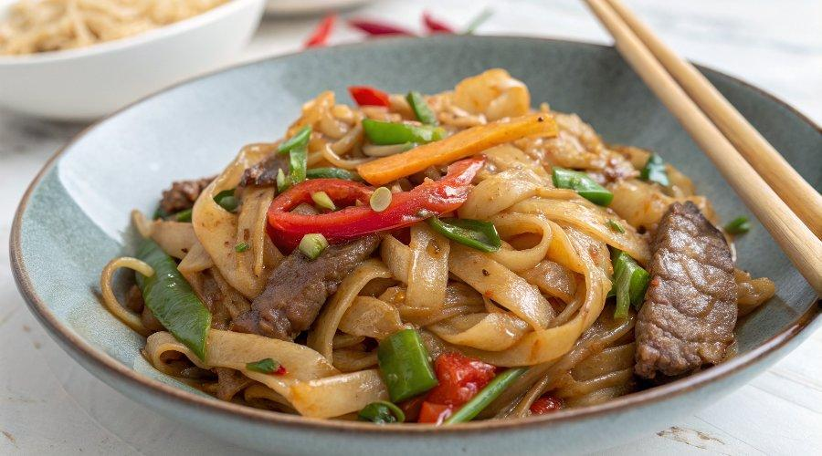

INGREDIENTS  - 200 g flat rice noodles (choose wide noodles, if possible)  - 2 tbsp neutral-tasting oil (such as vegetable)  - 3 garlic cloves finely chopped  - 3 bird’s-eye chillies finely chopped  - 225 g sirloin steak thinly sliced  - 100 g long-stemmed broccoli cut into 3-4cm (2-inch) pieces  - large handful of Thai basil leaves  - 3 1/2 tbsp light soy sauce  - 3 1/2 tbsp oyster sauce  - 1 tsp fish sauce  - 1 tbsp sugar | PREP  COOK  1. Prepare the noodles following pack instructions, then drain and set aside. Combine all the ingredients for the sauce in a small bowl or jug, and set aside.  2. Heat the oil in a large wok or frying pan over a high heat and stir-fry the garlic and chilli for 20 seconds until just starting to turn golden. Add the steak and stir-fry for 1 minute until seared and starting to brown. Add the broccoli and stir-fry for another minute, then tip in the noodles and add the sauce. Stir-fry for another 1-2 mins until well combined and piping hot.  3. Stir through the basil and turn off the heat. Serve immediately to avoid overcooking.  PLATING

