VEGAN EGGNOG  COOK TIME: 10 min  SOURCE:  #holiday #beverage #creamy | 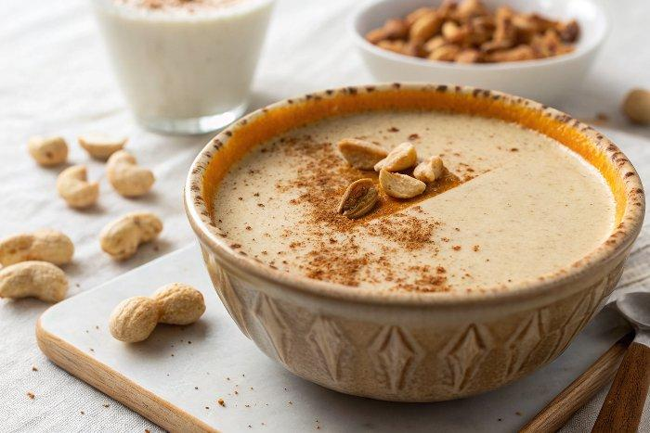

INGREDIENTS  - 1 cup (240ml) raw cashews (see notes for alternatives)  - 3 cups (720ml) non-dairy milk  - 1/4-1/2 cup granulated sugar or pure maple syrup  - 1 tsp pure vanilla extract  - 1/2 tsp ground nutmeg  - 1/2 tsp cinnamon  - 1/4 tsp cloves  - 1 oz whiskey or rum, per serving, optional | PREP  COOK  1. Bring 3 cups (720ml) of water to a boil. Pour the hot water over the cashews and let soak for 5 minutes.  2. Drain the cashews and discard the soaking water. Add them to a blender along with the non-dairy milk, sugar (you can start with the 1/4 cup), vanilla, nutmeg, cinnamon and cloves and blend until very smooth. Taste, add more sweetener or spices if needed.  3. Let it chill in the refrigerator for at least an hour before serving, it will thicken up and give the flavors time to mingle. Serve alcohol free or add 1 ounce of whiskey/rum to each glass, as desired. I also topped mine with a little coconut whipped cream and a sprinkle of nutmeg.  PLATING

