HOMEMADE VANILLA COFFEE SYRUP  COOK TIME: 10 min  SOURCE:  #sweet #homemade #beverage | 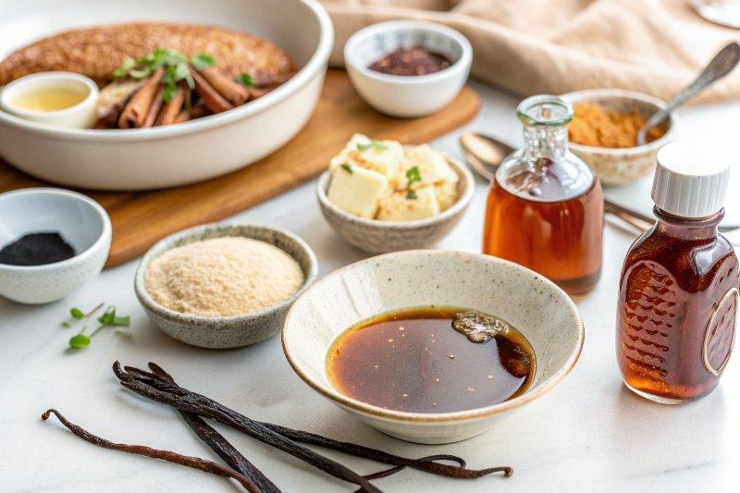

INGREDIENTS  - 1 3/4 cups water  - 1 1/2 cups granulated sugar  - 1/2 cup packed light brown sugar  - 1 vanilla bean (split in half)  - 2 tsp pure vanilla extract | PREP  COOK  1. In a medium saucepan over medium-high heat, whisk together water, sugar, and vanilla bean.  2. Bring to a boil and reduce heat.  3. Simmer for about five minutes - the sugar should be completely dissolved.  4. Remove from heat and stir in vanilla extract.  5. Once simple syrup has cooled, remove the vanilla bean and pour the syrup into a glass jar or bottle.  6. Store in refrigerator.  PLATING

