OLD-FASHIONED BEEF HAND PIES  COOK TIME: 4h  SOURCE:  #comfort-food #hearty #savory | 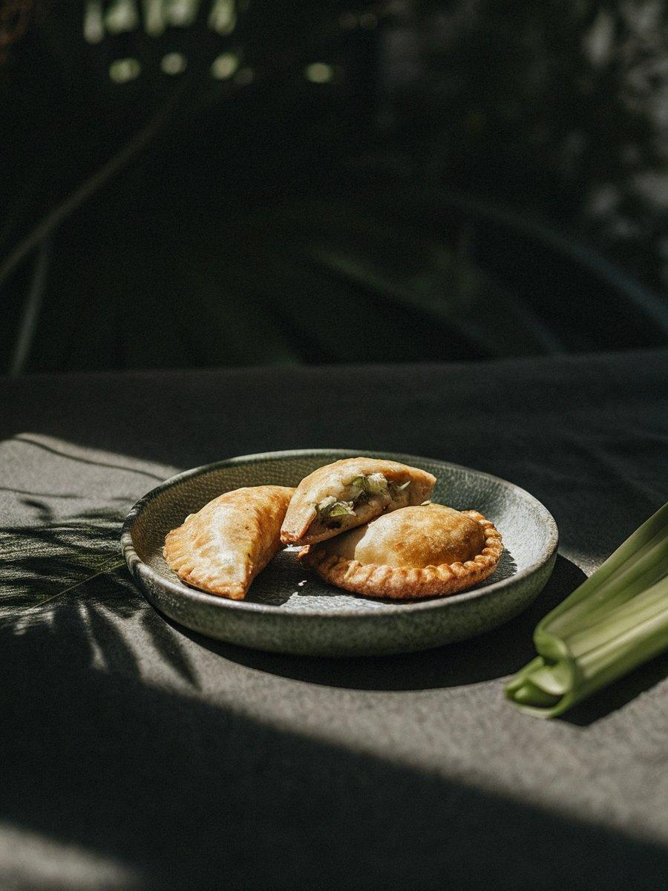

INGREDIENTS  - 1 tbsp vegetable oil  - 2 celery sticks chopped  - 1 onion chopped  - 2 large carrots chopped  - 1 bay leaf  - 850 g beef diced  - 1 tbsp butter  - 2 tbsp plain flour  - 2 tbsp tomato purée  - 600ml (2.5 cups) strong beef stock  - 3 x 320 g sheets of ready-rolled puff pastry  - 1 egg lightly beaten  - greens, mash and gravy to serve | PREP  COOK  1. Heat the oven to 160C/140C fan/gas  3. Heat the oil in a flameproof casserole dish over a medium-low heat and fry the celery, onion, carrots and bay leaves until softened. Stir in the diced beef (there’s no need to brown it), then the butter and flour, and finally the tomato purée and stock. Bring to a simmer.  2. Cover and cook in the oven for 2 hrs 30 mins, then uncover and cook for at least 30 mins more, or until the meat is very tender and the sauce thick. Leave to cool completely.  3. Turn the oven to 200C/180C fan/gas  6. Unroll the puff pastry sheets and stamp out eight rounds, roughly 14cm (6-inch) in diameter. Arrange four of the pastry rounds over two baking sheets lined with baking parchment, then divide the meat mixture between them, leaving a wide border around the edge. Brush the edge of each pie base with a little of the egg, then press on the pie tops. Crimp the edges using a fork to seal and cut a steam hole in the top of each. Brush with more beaten egg and bake for 30 mins, or until the pastry is golden and cooked through. Serve with greens, mash and gravy.  PLATING

