LASAGNE JACKETS  COOK TIME: 1h 45m  SOURCE:  #comfort-food #hearty #baked | 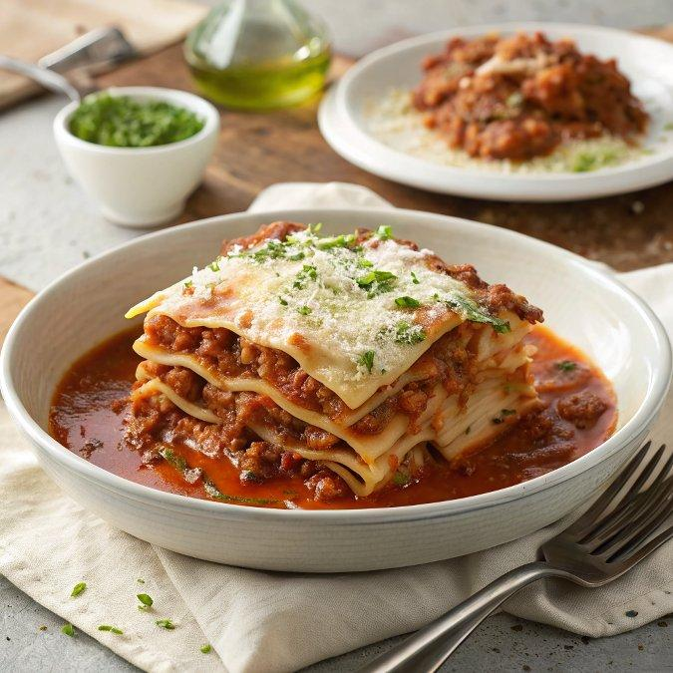

INGREDIENTS  - 4 potatoes  - 2 tsp olive oil  - 150 g grated mozzarella  - 30 g parmesan finely grated  - 2 tbsp olive oil  - 1 onion finely chopped  - 1 celery stick finely chopped  - 1 carrot finely chopped  - 3 garlic cloves crushed  - 500 g beef mince  - 3 tbsp tomato purée  - 150 ml red wine  - 2 bay leaves  - 400 g can of chopped tomatoes  - 400ml (1.7 cups) chicken or beef stock  - 25 g butter  - 25 g plain flour  - 250ml (1.0 cups) milk  - grating of nutmeg | PREP  COOK  1. Heat the oven to 200C/180C fan/gas  6. Prick the potatoes all over with a fork, then rub the skins with the 2 tsp oil. Bake for 1-1½ hrs until very tender when pressed and the skins are crisp.  2. While the potatoes are baking, make the ragu. Heat the olive oil over a medium heat in a large saucepan that has a lid. Fry the onion, celery and carrot with a pinch of salt for 10 mins until softened. Stir in the garlic and cook for a minute more. Add the mince, turn up the heat a little and fry the beef for 10 mins, breaking it up with a spoon, until browned.  3. Stir in the tomato purée, fry for a minute until darkened in colour, then add the wine, cook for a couple of minutes, and then add the bay. Simmer until reduced by half and pour in the can of tomatoes and the stock. Bring to a simmer, then turn the heat to low, cover with the lid and cook for 50 mins-1 hr until you have a rich ragu. Uncover for the last 20 mins to thicken the sauce if needed. Season well.  4. To make the béchamel, melt the butter in another saucepan over a medium heat. Sprinkle in the flour and mix well to create a thick paste. Cook the flour for 2 mins, then add the milk, a splash at a time, stirring continuously. Once all the milk has been incorporated, stir in the nutmeg and simmer for 3-4 mins until thickened enough to coat the back of a spoon. Season with salt and pepper.  5. Heat the oven to 220C/200C fan/gas  7. Split the jacket potatoes by cutting a cross into the tops and gently pressing the sides to create an opening. Transfer to a baking tray with a lip or a baking dish.  6. Divide half the mozzarella between the potatoes. Add a generous ladle of the ragu over the top, then a spoonful of the béchamel. Scatter over the remaining mozzarella, top with the parmesan and bake for 12 mins until the cheese melts and starts to turn golden.  PLATING

