BAKLAVA  COOK TIME: 50 min  SOURCE:  #sweet #layered #traditional | 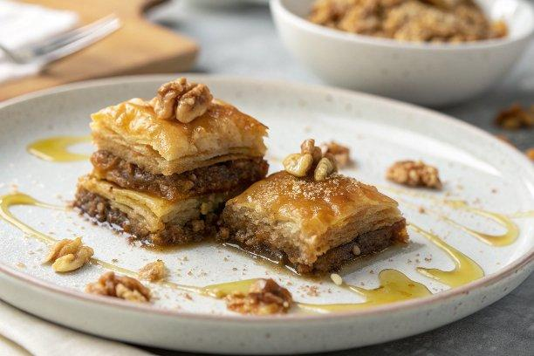

INGREDIENTS  - 1 cup (240ml) water (240 mL)  - 1 cup (240ml) honey (340 g)  - 1/2 cup granulated sugar (100 g)  - zest and juice of 1 lemon  - 1 lb chopped nuts (walnuts or pistachios (450 g)  - 1/4 cup granulated sugar (50 g)  - 1 tsp ground cinnamon  - 16 oz phyllo dough (thawed (450 g)  - 3/4 cup butter (melted (170 g) | PREP  COOK  1. Honey Syrup:  2. Combine water, honey and sugar in a saucepan. Bring to a boil over medium-high heat and cook for 10 minutes, stirring occasionally. Stir in the lemon zest and juice and remove from the heat. Let cool while making the baklava. (Be sure to make this first as the syrup needs to be fully cooled by the time the baklava is done.)  3. Baklava:  4. Preheat the oven to 350F.  5. Place the nuts in a food processor and pulse until finely ground. Transfer them to a large bowl and stir in sugar and cinnamon until combined.  6. Unfold phyllo. Trim to fit a 13x9-inch (33x23cm) baking pan. Cover with a tamp tea towel to keep the dough from drying out.  7. Brush bottom and sides of a 13x9-inch (33x23cm) baking pan with melted butter. Lay a sheet of phyllo dough in the bottom of the pan and brush with melted butter. Repeat 9 more times, creating a layer of 10 phyllo sheets.  8. Sprinkle and spread a third (about 1 1/4 cups) of the nut mixture evenly over the phyllo.  9. Top with a phyllo sheet and brush with butter. Repeat 5 more times, creating a layer of 6 phyllo sheets. Cover with another third of the nut mixture. Repeat both phyllo and nut layers again.  1  0. Top the nut mixture with 1 phyllo sheet and brush with butter. Repeat 9 more times, creating a top layer with 10 phyllo sheets. Brush with butter.  1  1. Using a very sharp knife, cut the baklava into 2-inch (5cm) wide strips. Cut into the same width strips again running diagonally to the first cuts, creating a diamond pattern.If any melted butter remains, Drizzle it all over the pan.  1  2. Bake for 50 minutes or until golden brown.  1  3. Right when the baklava is removed from the over, immediately pour the honey syrup all over. (It should make a sizzling sound.) Let the honey syrup soak into the baklava for about 6 hours before serving. Garnish with finely chopped nuts, if desired.  PLATING

