MYOGA YUKARI RICE (MAZEGOHAN)  COOK TIME: 10 min  SOURCE:  #quick #comfort-food #rice | 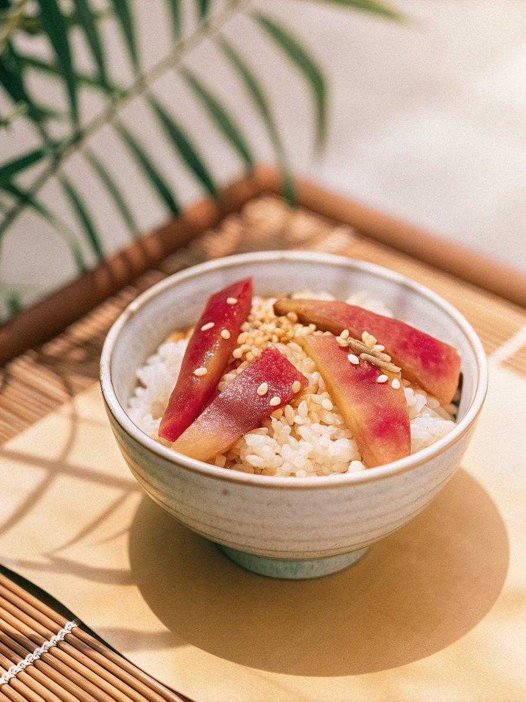

INGREDIENTS  - 3 myoga ginger  - 2 bowls cooked Japanese short-grain rice (freshly cooked; typically 1 cup, 150 g per bowl)  - 2 tsp yukari rice seasoning  - 2 tsp toasted white sesame seeds | PREP  COOK  1. Gather all the ingredients.  2. Discard the bottom ends of 3 myoga ginger. Thinly slice the myoga diagonally.  3. Run a large bowl (here I used a sushi oke, but you can also use a baking sheet) under cold water to make it wet, so the rice won‘t stick. Add 2 bowls cooked Japanese short-grain rice and 2 tsp yukari rice seasoning to the bowl and mix them all together.  4. Add 2 tsp toasted white sesame seeds and the thinly sliced myoga ginger.  5. Gently mix together with a rice paddle (scooper) in a slicing motion so that the rice doesn‘t get mushy. Serve in rice bowls and enjoy!  6. To Store  7. You can keep any leftover rice in an airtight container and store it in the freezer for a month. I don‘t recommend refrigerating rice as it gets hard. I freeze my rice even when I plan to eat it the next day.  PLATING

