COBB SALAD PIZZA  COOK TIME: 10 min  SOURCE:  #pizza #salad #comfort-food | 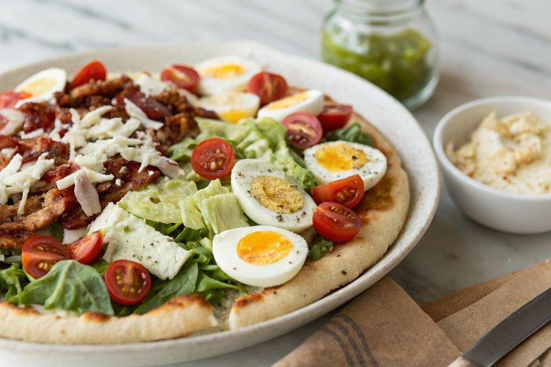

INGREDIENTS  - 2 tsp instant yeast  - 225 g plain flour plus extra for dusting  - 1 tsp golden caster sugar  - extra virgin olive oil for shaping the dough and drizzling  - 3 tbsp extra virgin oilve oil  - 2 tbsp tomato purée  - 2 tbsp red wine vinegar  - 1/2 tbsp Dijon mustard  - 2 garlic cloves crushed  - 1 tsp dried oregano  - 100 g stilton crumbled  - 2 hard-boiled eggs peeled and roughly chopped  - 1 romaine lettuce shredded  - 1/2 cucumber deseeded and finely cubed  - 110 g tomatoes halved  - 1/2 red onion thinly sliced  - 160 g cooked chicken slices shredded  - handful of finely chopped parsley to serve | PREP  COOK  1. If you're making your own dough, measure 150ml warm water into a jug and stir in the yeast. Set aside for 10 mins until foamy. (If you're using two shop-bought bases, skip to step 6.)  2. Meanwhile, combine the flour, 2 tsp salt and the sugar in a large bowl. Make a well in the centre and after the 10 mins are up, pour in the water and yeast mixture, then combine using clean hands or a wooden spoon.  3. Form the dough into a ball using lightly oiled hands. Knead on a lightly floured surface for 5-10 mins until smooth. Wipe out the bowl and lightly coat with oil. Put the dough in the bowl, cover and leave to prove in a warm place until doubled in size, about 1 hr.  4. Punch the air out of the dough, then divide into two balls using lightly oiled hands. Put on a lightly floured surface, cover with a damp tea towel and leave to rest for 30 mins.  5. Heat the oven to 240/200 fan/gas  8. Stretch the dough out into two round bases, then transfer to two separate baking trays (ideally ones with holes in the bottom, which helps create a crispy crust).  6. Whisk the dressing ingredients together, then brush a little over each pizza base. Divide the stilton between the bases. Bake for 8-10 mins until crisp and the cheese is melted.  7. Meanwhile, combine the remaining topping ingredients with the remaining dressing. Pile on top of the pizzas, sprinkle over the parsley and slice to serve.  PLATING

