SSAMJANG RECIPE  COOK TIME: 5 min  SOURCE:  #quick #dipping-sauce #asian-flavors | 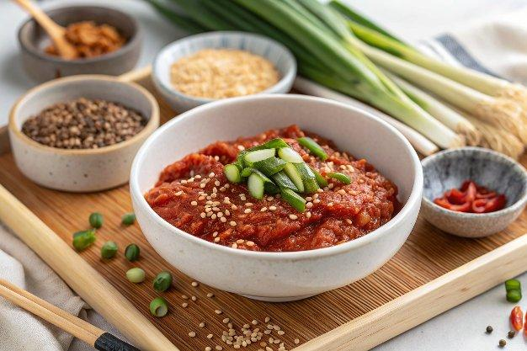

INGREDIENTS  - 1/4 cup doenjang (Korean soybean paste)  - 2 Tbsp gochujang (Korean chili paste)  - 2 Tbsp toasted sesame oil  - 1/2 Tbsp honey  - 2 tsp toasted sesame seeds  - 1/2 tsp minced garlic  - 10 g onion (, thinly sliced)  - 2 Tbsp walnuts (or your choice of nuts and seeds) – this will add nuttier flavor and creamier texture.)  - 10 g apple (, cored and cut into small pieces)  - green onion (optional)  - green chilies (optional)  - toasted sesame seeds (optional) | PREP  COOK  1. Put all ingredients in a food processor and blend until the texture is smooth. It will takes about 1 min. Transfer the sauce into a serving bowl. Garnish with the green onion and sesame seeds.  PLATING

