MOCHA CAKE  COOK TIME: 35 min  SOURCE:  #chocolate #baking #comfort-food | 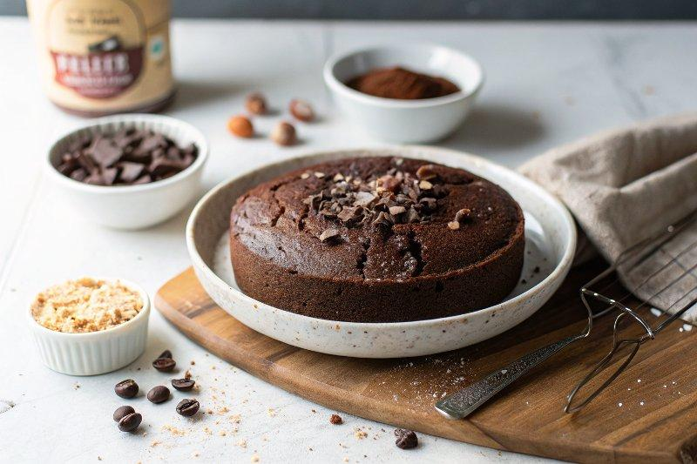

INGREDIENTS  - Butter (for greasing the pan)  - 1/2 cup all-purpose flour  - 1/4 cup whole wheat pastry flour (plus 2 tbsp)  - 1 cup (240ml) granulated sugar  - 1/4 cup unsweetened cocoa powder (plus 2 tbsp, plus extra for the pan)  - 2 tsp espresso powder  - 1 tsp baking soda  - 1/2 tsp baking powder  - 1/2 tsp kosher salt  - 1/2 cup low fat buttermilk  - 1/4 cup coconut oil (melted and cooloed)  - 1 large egg (at room temperature)  - 1 tsp pure vanilla extract  - 1/2 cup freshly brewed hot coffee  - 4 oz reduced fat cream cheese (at room temperature)  - 3 tbsp unsalted butter (at room temperature)  - 1 tbsp brewed coffee (at room temperature or cold)  - 1 tsp espresso powder  - 1/2 tsp pure vanilla extract  - 1 1/2 cups powdered sugar  - 1/4 cup unsweetened cocoa powder  - 1/8 tsp salt  - Chopped chocolate covered espresso beans (for decorating) | PREP  COOK  1. Butter  2. Preheat the oven to 350°F (175°C). Butter and lightly dust with cocoa powder a 6-cup bundt pan or an 8-inch (20cm) x 2-inch (5cm) round cake pan, tapping out the excess. If using a round cake pan, line the bottom with parchment paper, then butter and dust with cocoa again.  3. Whisk  4. Into the bowl of a standing mixer fitted with the paddle attachment or a large mixing bowl, briskly whisk together the all-purpose flour, whole wheat pastry flour, sugar, cocoa powder, espresso powder, baking soda, baking powder, and salt until well combined and no lumps remain.  5. Mix  6. In a separate bowl, combine the buttermilk, oil, eggs, and vanilla until well blended. With the mixer running on low speed, slowly pour the wet ingredients into the dry. Then, keeping the mixer running on low, pour in the coffee and mix gently, just until combined. Scrape the bottom of the bowl with a rubber spatula to ensure all ingredients are blended.  7. Bake  8. Pour the batter into the prepared pan and bake for 35 to 40 minutes, until a toothpick inserted in the center of the cake comes out clean (either of the two pans will bake in this amount of time). Remove from the oven, place the pan on a wire rack, then let the cake cool in the pan for 30 minutes. Carefully invert onto a serving plate.  9. Beat  1  0. Prepare the frosting: in a large mixing bowl, beat together the cream cheese and butter on medium speed until light and fluffy.  1  1. Mix  1  2. In a small bowl, stir together the coffee, espresso powder, and vanilla extract so that the espresso powder dissolves, then add the mixture to the bowl with the cream cheese and butter and beat until combined. In a separate bowl, sift together the powdered sugar, cocoa powder, and salt. With the mixer on low, slowly add the powdered sugar mixture to the cream cheese. Mix until well blended. Add a little more liquid coffee or powdered sugar as needed to reach the desired consistency. Spread over the cooled cake. Sprinkle immediately with chopped chocolate covered espresso beans. Dive in!  PLATING

