RASPBERRY POLENTA CAKE  COOK TIME: 30 min  SOURCE:  #cake #fruit #baking | 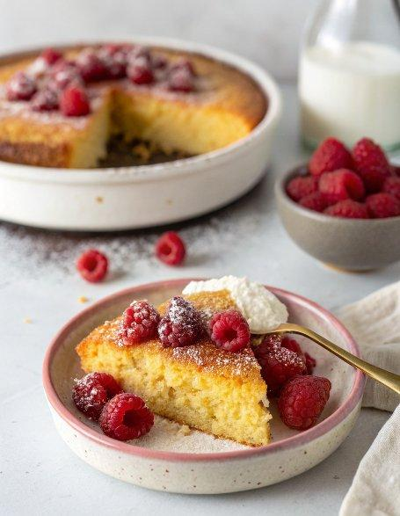

INGREDIENTS  - 1/2 cup all purpose flour  - 1/2 cup finely ground polenta  - 1/2 tsp baking powder  - 1/4 tsp baking soda  - 1/4 tsp salt  - 1/2 cup almond milk  - 1/4 cup maple syrup  - 1/4 cup melted coconut oil  - 1/2 cup raspberries  - optional: a few drops of lemon oil, vanilla, and/or a pinch of cinnamon  - more coconut oil or butter to grease the skillet | PREP  COOK  1. Preheat your oven to 350°F (175°C), with an 8 or 10-inch (25cm) cast iron skillet inside. (pictured is a 10-inch skillet)  2. Mix your dry ingredients.  3. In a separate bowl whisk together (by hand) your wet ingredients.  4. Combine both and whisk together until well combined, but don't overmix.  5. Remove hot skillet from the oven, grease it with a little coconut oil or butter (or vegan butter), then pour in the batter. Sprinkle raspberries on top and bake it for approx. 18-25 minutes or until a toothpick comes out clean.  6. Let cool slightly, then serve hot with ice cream.  PLATING

