WASHED FLOUR SEITAN  COOK TIME: 1h 10m  SOURCE:  #protein-rich #meat-alternative #homemade | 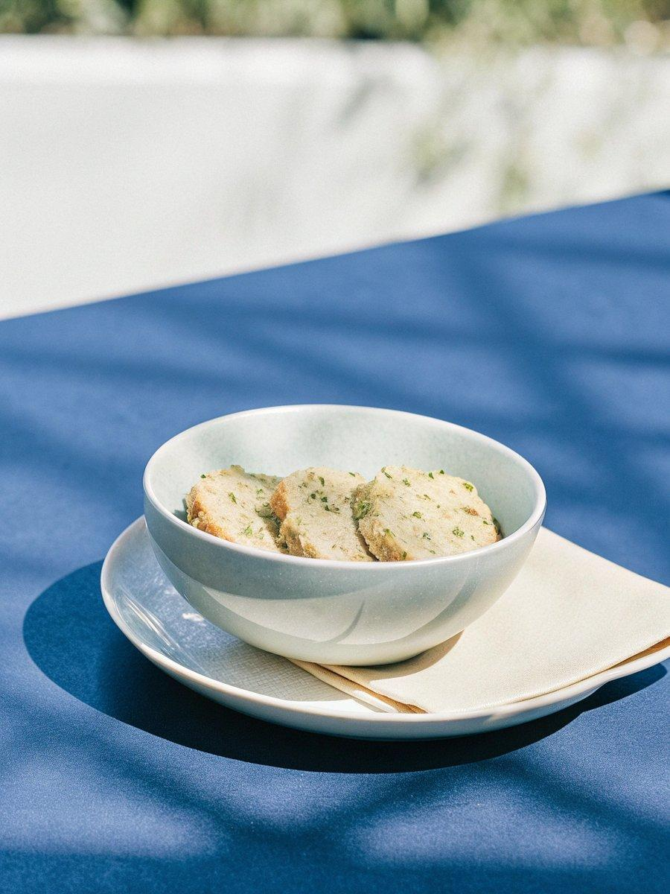

INGREDIENTS  - 7 cup (1680ml) bread flour  - 3 cup (720ml) water  - 1 Tbsp vegetable oil  - 1 small onion  - 1 carrot  - 1 celery rib  - 2 garlic clove  - 6 cup (1440ml) water  - 1/4 cup sodium-reduced soy sauce  - 2 Tbsp white miso paste  - 4 dried shiitake mushroom  - liquid smoke | PREP  COOK  1. Mix the flour and water to form a dough.  2. Knead the dough for 5 - 7 minutes.  3. Rest the dough in water for 1 hour.  4. Drain and replace the water and knead the dough in the water for 3 - 5 minutes.  5. Drain the water and repeat adding new water and "washing" the seitan until the water is fairly clear. This might take 4 - 5 washing cycles. The more the seitan is washed, the tougher and more fibrous it becomes. Depending on the texture desired, do less or more washing cycles.  6. Let the dough rest in an empty bowl for at least 20 - 30 minutes. It will release water as it rests.  7. Meanwhile, heat the oil in a large pot over medium-high heat. Cook the onion, carrot, celery, and garlic until golden.  8. Add the remaining broth ingredients and bring to a gentle simmer.  9. To braid the seitan, leave an inch (2 cm) of the dough intact at one end. Cut two parallel slits along the length of the dough, then braid the three sections.  1  0. Pull the braid slightly to stretch the dough and wrap it into a knot.  1  1. Place the seitan knot into the simmering broth. Partially cover the pot with the lid, and cook for 1 hour. If the seitan isn't fully submerged, turn the seitan once or twice during the cooking process.  1  2. Remove the seitan from the broth and strain out the solids from the broth*.  1  3. Store the seitan, as is, in the broth liquid, or shred into bite-sized pieces before storing.  1  4. Drain before using in your favourite recipes. Enjoy!  PLATING

