PEAR AND ALMOND TART  COOK TIME: 45 min  SOURCE:  #sweet #baked #fruit | 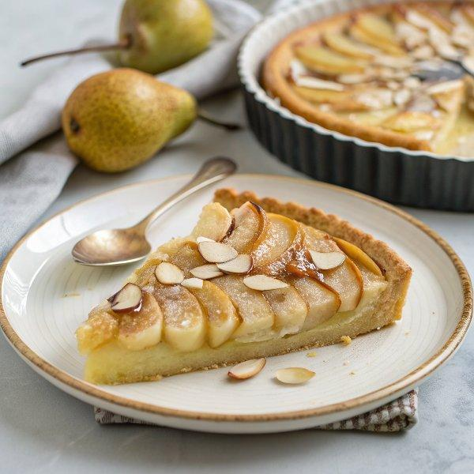

INGREDIENTS  - 1 Homemade Sweet Tart Crust (9–10 inch, 23–25 cm; you can follow my recipe)  - 1/2 cup unsalted butter (1 stick, 8 Tbsp; at room temperature) 1 8  - 1 cup (240ml) confectioners’ sugar (or substitute 1/2 cup, 100 g granulated sugar) 1/2 100  - 1 cup (240ml) almond flour  - 2 Tbsp all-purpose flour (plain flour)  - 1/4 tsp Diamond Crystal kosher salt  - 2 large eggs (50 g each w/o shell) (at room temperature)  - 1 tsp pure vanilla extract  - 1 Tbsp rum (optional)  - 1 tsp almond extract (increase to 1 1/2 tsp if you skip the rum) 1 1/2  - 3 Bartlett or Anjou pears (small; you can also use canned pear halves, drained and dried well)  - 1/2 lemon  - 3 Tbsp apricot jam  - 1 tsp confectioners’ sugar (for serving)  - 1 Tbsp sliced almonds (for serving) | PREP  COOK  1. Before You Start...  2. I highly encourage you to weigh your ingredients using a kitchen scale for this recipe. For weights, click the Metric button above. If you‘re using a cup measure, please follow the “fluff and sprinkle“ method: Fluff your flour with a spoon, sprinkle it into your measuring cup, and level it off. Otherwise, you may scoop more than you need. Also, I encourage you to check your oven‘s temperature with an oven thermometer, as the actual temperature inside may differ from the display setting.  3. To Make the Sweet Tart Crust  4. Make 1 Homemade Sweet Tart Crust that‘s “partially baked“ following my recipe. Cool the pastry case before filling. Make in advance: You can make the partially-baked crust ahead of time, then wrap well and keep at room temperature for up to 2 days. You can also refrigerate it for up to 1 week or freeze it for up to 2 weeks.  5. To Make the Almond Cream Filling (Frangipane)  6. Gather all the ingredients. Take out the butter and eggs from the refrigerator and bring them to room temperature. If needed, soak the cold eggs for 5 minutes in warm (not hot!) water until they reach room temperature. Tip: Cold eggs will reduce the temperature of the butter, making emulsion difficult.  7. In a large bowl with a hand mixer or stand mixer, cream ½ cup unsalted butter (at room temperature and softened).  8. Add 1 cup (240ml) confectioners’ sugar and mix well until the mixture resembles a coarse meal.  9. Add 1 cup (240ml) almond flour, 2 Tbsp all-purpose flour (plain flour), and ¼ tsp Diamond Crystal kosher salt, and mix well.  1  0. Add 2 large eggs (50 g each w/o shell) one at a time. Incorporate well into the mixture before adding the next egg. Tip: Make sure you add them gradually. Adding the eggs all at once inhibits emulsion, and results in a “scrambled-egg“ appearance.  1  1. Add 1 tsp pure vanilla extract, 1 tsp almond extract, and 1 Tbsp rum.  1  2. Whisk until homogenized and smooth. Make in advance: You can keep the almond cream in the refrigerator for up to 3–5 days or in the freezer for weeks.  1  3. To Assemble the Tart  1  4. Preheat the oven to 375ºF (190ºC). For a convection oven, reduce the cooking temperature by 25ºF (15ºC). Heat 3 Tbsp apricot jam and 1 Tbsp water in the microwave for 10 seconds until liquified. Brush a thin layer of the jam on the bottom of the empty pastry crust to prevent a soggy bottom. Reserve the remaining jam for later. Then, fill the tart crust with the almond cream, smoothing out to the edges with an offset spatula. Refrigerate for 30 minutes until set.  1  5. Meanwhile, peel 3 Bartlett or Anjou pears, cut each in half lengthwise, and scoop out the cores.  1  6. Cut each half crosswise into ⅛-inch (3-mm) slices. Rub the pears with the juice from ½ lemon to prevent browning.  1  7. Take out the tart from the refrigerator. Gently press each pear half on the work surface to fan out the slices toward the stem/top end. Transfer the pear halves one at a time by sliding the knife under each one.  1  8. Arrange each pear half on top of the filling with the tapered (stem) end pointing toward the center of the tart. The slices should fan and lean toward the center. Make sure to leave space around the pear halves so they are not touching, as the filling will puff up and they need room to expand.  1  9. To Bake the Tart  2  0. Bake the tart at 375ºF (190ºC) until golden brown or a bamboo skewer inserted into the center of the filling comes out clean, about 40–45 minutes.  2  1. Remove the tart from the oven and let cool in the pan on the wire rack. Brush the pears with the leftover apricot jam. Once it’s cool, carefully unmold the tart.  2  2. To Serve  2  3. Toast 1 Tbsp sliced almonds in a frying pan (no oil) until golden, about 5 minutes.  2  4. Sprinkle 1 tsp confectioners’ sugar and toasted almond slices on top, if desired, and serve slightly warm. Cut into wedges and enjoy!  2  5. To Store  2  6. Store the tart in the refrigerator for up to 3 days. Slightly reheat the tart before serving.  PLATING

