CHOCOLATE MACARONS  COOK TIME: 15 min  SOURCE:  #chocolate #baking #sweet | 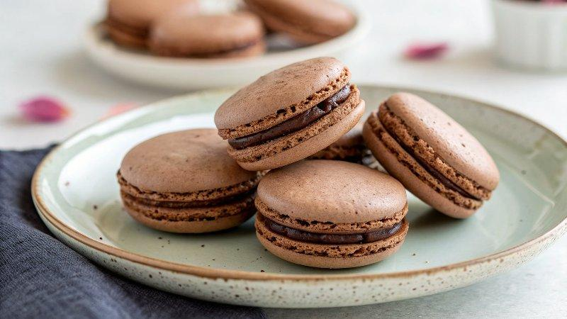

INGREDIENTS  - 105 g finely sifted or super-fine almond flour, (preferably Blue Diamond Finely Sifted Almond Flour)  - 95 g confectioners' sugar  - 10 g Hershey's unsweetened cocoa powder  - 100 g egg whites, (from approximately 3 large eggs)  - 100 g granulated sugar  - 1 tsp vanilla bean paste  - 1 to 2 drops brown gel paste food color  - 6 tbsp heavy cream  - 4 oz semi-sweet chocolate  - 1/2 tbsp butter  - 1 tsp rum (optional)  - Heavy-duty stand mixer  - Digital scale  - Pastry bag with 1/2-in (13-mm) tip  - Parchment paper or Silpat baking mat/template | PREP  COOK  1. Fill a small saucepan with about 1 in (2.5-cm) of water. Bring to a simmer on the stove over medium-low heat. Line two 13 x 18-in (33 x 46-cm) baking sheets with parchment paper or silpat baking mats. Place the pastry bag fitted with the ½-in (13-mm) tip in a wide glass with the tip at the bottom of the glass but facing up (this prevents the batter from spilling out when you fill the bag). Fold the bag over the rim of the glass to form a cuff.  2. In a large bowl, sift the almond flour, confectioners' sugar, and cocoa powder together through a fine sieve. Alternatively, if your almond flour is too coarse to go through the sieve, combine the almond flour, confectioners' sugar, and cocoa powder in the bowl of a food processor fitted with the metal blade and pulse 10 to 15 times to blend.  3. Add the egg whites and granulated sugar to the bowl of a stand mixer; whisk with a handheld whisk to combine. Place the bowl over the saucepan of simmering water, making sure the bottom of the bowl is not touching the water. Whisk constantly until the sugar is completely dissolved and the egg whites are very warm to the touch, about 2 minutes. (To see if it's ready, rub the mixture between your fingers to see if you can feel any sugar granules.)  4. Remove the bowl from the heat and attach to the stand mixer fitted with the whisk attachment. Mix on medium-low speed (speed 4) for 2 minutes. Increase the speed to medium-high (speed 8) and mix until the meringue is glossy and holds stiff peaks, about 6 minutes. You'll know it's ready when you lift the whisk out of the bowl and the peaks stand straight up, curling over just slightly at the tip.  5. Pour the sifted almond flour, confectioners' sugar and cocoa powder mixture into the bowl with the meringue. Add the vanilla bean paste and food coloring. Using a rubber spatula, fold until evenly incorporated. At this point, the batter will be very thick. To achieve the right consistency, continue folding, alternately smearing the batter against the bottom and sides of the bowl, until it is glossy with a lava-like consistency. This process is called "macronage" and takes approximately 3 to 5 minutes. You'll know the batter is ready when you can lift up the spatula and slowly form several figure 8s with the batter without the ribbon breaking. Additionally, the batter from your figure 8 should dissolve into the batter that’s already in the bowl in 10 to 15 seconds. (Another test to be sure the batter is properly mixed: Scoop up a teaspoon of batter and place it onto the parchment paper. Wait a minute to see how it behaves. It should gently spread and the point should dissipate into the batter. If the batter fails to spread out, continue folding and then test again.) Be careful not to overmix or you'll end up with macaron puddles; it's always best to undermix and test several times until the proper consistency has been achieved.  6. Transfer the batter to a large pastry bag fitted with a ½-in (13-mm) round pastry tip. Hold the bag straight up and down, perpendicular to the pan, and about ½ in (13-mm) above it, and pipe out 1¼-in (3-cm) diameter mounds onto the parchment paper. (To avoid leaving a point on the mounds, finish piping by releasing pressure and pulling up as you quickly twist with a flick of your wrist.) Tap each tray several times on the countertop to pop any air bubbles. Use a toothpick to pop any remaining air bubbles on the surface of the shells. Allow the trays to rest for about 20 minutes, or until the shells have dried out slightly.  7. Meanwhile, preheat the oven to 325°F (165°C) and set an oven rack in the middle position.  8. Bake, one pan at a time, for 12 to 14 minutes, or until the tops are shiny and crisp. Set the pans on wire racks and let cool completely.  9. Make the shells up to a day ahead of making the final macarons; store the shells in a covered container in the refrigerator. (It's fine to stack the shells; just be gentle with them.) You can also freeze the shells in a tightly sealed container for about two weeks. Make sure to thaw them in the refrigerator for a few hours before assembling.  1  0. Prepare the chocolate ganache filling: Pour the cream into a medium microwave-safe bowl. Microwave on high until boiling, about 1 minute. Add the chocolate and butter; let sit for 1 minute, then whisk until smooth and glossy. (Alternatively, put the chocolate and butter in a medium bowl, bring the cream to a boil in a saucepan, and then pour the cream over the chocolate and butter.) Whisk in the rum, if using. Allow the ganache to cool, whisking it occasionally, until it is thickened enough to spread with a knife. (Don't let it cool for too long, or it will be too firm to spread.)  1  1. Remove the macarons from the parchment paper, and turn half of them over. Spoon a generous teaspoon of ganache in the center of an upside-down macaron. Top with a second macaron and press gently to spread the filling to the edges. Repeat with the remaining macarons. Serve the macarons on the day they are made or store in a covered container in the refrigerator for up to 2 days; bring to room temperature before serving.  PLATING

