SPINACH ARTICHOKE ENCHILADAS  COOK TIME: 25 min  SOURCE:  #comfort-food #healthy #quick | 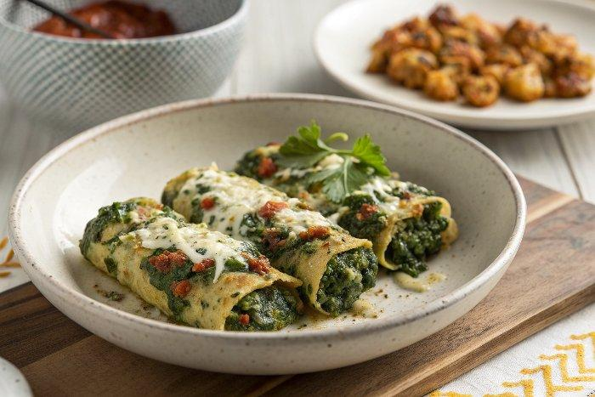

INGREDIENTS  - 3 tbsp olive oil  - 3 tbsp whole wheat or all-purpose flour  - 2 tsp ground chili powder  - 1 tsp cumin  - 1/2 tsp garlic powder  - 1/4 tsp dried oregano  - 1/4 tsp salt  - 1/8 tsp ground cinnamon  - 2 tbsp tomato paste  - 2 cups (480ml) vegetable broth  - 1 tsp apple cider vinegar or distilled white vinegar  - Freshly ground black pepper, to taste  - 2 tbsp olive oil  - 1 cup (240ml) chopped red onion (about 1 small red onion)  - 1/4 tsp salt  - 4 cloves garlic, pressed or minced  - 1 heaping cup drained artichokes (either jarred or defrosted frozen), quartered if necessary  - 1 (4-oz) can green chilis, drained  - 12 oz baby spinach, preferably organic  - 1 (15-oz) can black beans, drained and rinsed  - 1/4 cup sour cream  - Freshly ground black pepper, to taste  - 6 (8-inch) whole wheat tortillas  - 1 cup (240ml) shredded Monterey Jack cheese  - Handful chopped cilantro, for garnish | PREP  COOK  1. Before you make the sauce, measure the flour and spices into a small bowl and place your tomato paste near the stove. In a medium-sized pot over medium heat, warm the oil until shimmering (it should be warm enough that the spices sizzle on contact). Pour in the flour and spice mixture. While stirring constantly with a whisk, cook until fragrant and slightly deepened in color, about 1 minute. Whisk the tomato paste into the mixture, then slowly pour in the broth while whisking constantly to remove any lumps.  2. Bring the mixture to a simmer, then reduce heat as necessary to maintain a gentle simmer, whisking often, for about five minutes, until the sauce has thickened a bit and a spoon encounters some resistance as you stir it. (The sauce will further thicken as it cools.) Remove from heat, then whisk in the vinegar and season to taste with a generous amount of freshly ground black pepper. Set aside.  3. To make your enchiladas, preheat the oven to 400°F (200°C) with racks in the middle position and upper third. Lightly grease a 13 by 9-inch (23cm) pan.  4. In a large skillet, warm 2 tablespoons olive oil over medium heat. Once the oil is shimmering, add the chopped onion and ¼ teaspoon salt. Cook, stirring often, until the onion is tender and translucent, about 4 to 5 minutes. Add the garlic and cook, stirring constantly, until fragrant, about 30 seconds.  5. Add the drained artichokes and green chilis to the skillet, then add a few large handfuls of spinach. Cook, stirring and tossing frequently, until the spinach has wilted. Repeat with remaining spinach. Continue cooking, stirring frequently, until the pan is no longer wet with excess moisture. Remove from heat and transfer the mixture to a bowl. Stir in the drained black beans and sour cream. Season to taste with salt and pepper.  6. Pour ½ cup enchilada sauce into your prepared pan and tilt it from side to side until the bottom of the pan is evenly coated. To assemble your first enchilada, spread ½ cup spinach artichoke mixture down the middle of a tortilla, then snugly wrap the left side over and then the right, to make a wrap. Place it seam side down against the edge of your pan. Repeat with remaining tortillas and filling. Drizzle the remaining enchilada sauce evenly over the enchiladas, leaving the very ends of the enchiladas bare. Sprinkle shredded cheese evenly over the enchiladas.  7. Bake, uncovered, on the middle rack for 20 minutes. If the cheese on top isn’t golden enough for your liking, carefully transfer the enchiladas to the upper rack of the oven and bake for an additional 3 to 5 minutes, until sufficiently golden and bubbly.  8. Remove from oven and let the enchiladas cool for 10 minutes (trust me!), then sprinkle chopped cilantro on top and serve.  PLATING

