BUTTERNUT SQUASH & BLACK BEAN WRAP  COOK TIME: 5 min  SOURCE:  #healthy #quick #wrap | 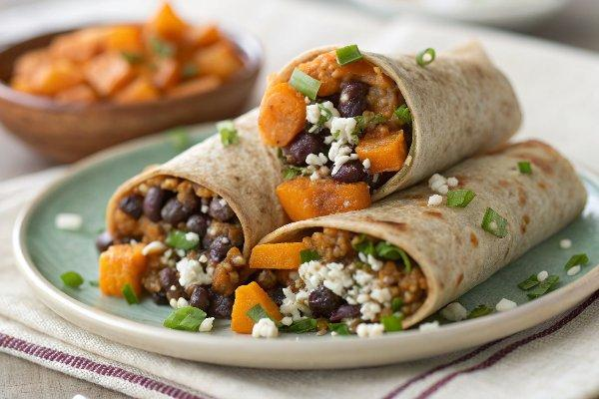

INGREDIENTS  - 3 cups (720ml) chopped butternut squash, steamed or roasted  - 1 cup (240ml) cooked quinoa  - 1 cup (240ml) rinsed black beans  - chopped scallions  - whole wheat wraps  - white crumbly cheese (feta, gorgonzola, cotija, etc.) | PREP  COOK  1. Mix first four ingredients together; season with whatever suits your fancy.*  2. Place 1 cup (240ml) of filling on a wrap, sprinkle with cheese, and fold it up.  3. Grill on a griddle or panini press.  PLATING

