OVERNIGHT FRENCH TOAST CASSEROLE  COOK TIME: 45 min  SOURCE:  #comfort-food #make-ahead #casserole | 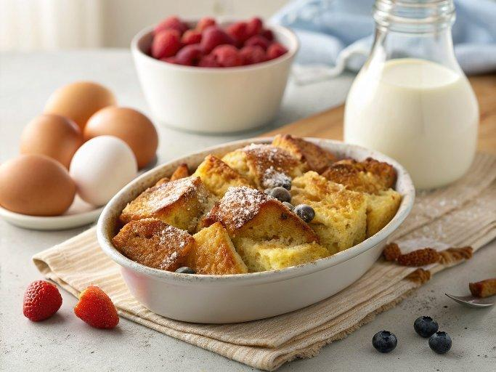

INGREDIENTS  - 3 Tbsp granulated sugar  - 3/4 tsp ground cinnamon  - 1 pinch ground nutmeg  - 6 large eggs  - 1 cup (240ml) milk ((anything but skim))  - 1 cup (240ml) half and half  - 1 1/2 tsp vanilla extract  - 1 (14.5 - 16 oz) loaf sourdough bread*, (cut into 1-inch slices then slices cut into 1-inch cubes*)  - 2 Tbsp melted butter, (plus more butter for baking dish)  - Powdered sugar, (for dusting (about 1 tsp))  - Real maple syrup or pancake syrup, (for serving)  - 1/3 cup (46 g) all-purpose flour  - 1/3 cup (78 g) packed light brown sugar  - 3/4 tsp ground cinnamon  - 1/8 tsp salt  - 1/4 cup (56 g) unsalted butter, (cold and diced into small cubes) | PREP  COOK  1. For the French toast: Butter a 13 by 9-inch (23cm) baking dish. Add bread cubes to baking dish spreading them into an even layer. In a mixing bowl with a pour spout** whisk together sugar, cinnamon and nutmeg.  2. Add in eggs and whisk until well blended, while scraping bowl. Pour in milk, half and half and vanilla and whisk until well blended.  3. Slowly and evenly pour egg mixture over bread cubes working to coat all of them (if you miss a few just turn and dunk them into the custard that's in the dish). Cover with plastic wrap and chill overnight, or at least 10 hours.  4. In the morning preheat oven to 350 degrees and while oven is preheating remove casserole from fridge and let rest at room temperature, it should rest about 15 minutes. Also, prepare crumble while oven is preheating.  5. For the crumble: In a medium mixing bowl whisk together flour, brown sugar, cinnamon and salt.  6. Add butter and cut into flour mixture using a pastry cutter or a long pronged fork until mixture resembles coarse crumbs, transfer to fridge if oven hasn't fully preheated yet then add it just before placing casserole in oven.  7. Sprinkle casserole evenly with crumble then bake in preheated oven until set and center is cooked through and no longer soggy, about 38 - 45 minutes.  8. Let cool a few minutes, pour melted butter over top, dust with powdered sugar if desired, then cut into squares and serve warm drizzling each serving with maple syrup.  PLATING

