10 MINUTE PEANUT BUTTER POPCORN  COOK TIME: 8 min  SOURCE:  #quick #comfort-food #sweet | 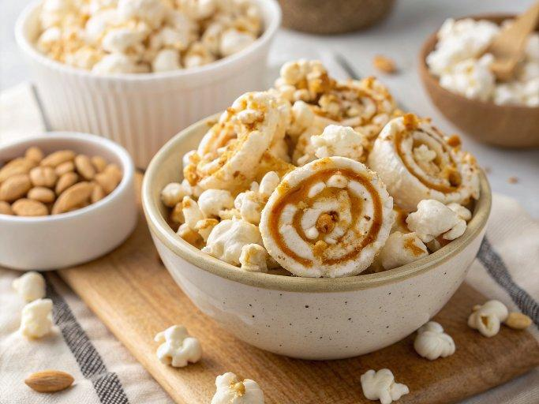

INGREDIENTS  - 1/3 cup popcorn kernels  - 1 tbsp white sugar  - 1 tbsp vegan butter ((I used Earth Balance brand))  - 1 tbsp natural peanut butter  - 1/4 tsp vanilla extract | PREP  COOK  1. Pop the popcorn in an air popper, or pop with whatever method you normally use (stove top or in the microwave works fine too).  2. In the meantime, add the sugar, vegan butter, peanut butter, and vanilla extract to a small pot. Put over medium heat and stir together until the sugar is dissolved about 3 minutes. Remove from heat and drizzle across the popped popcorn while shaking the bowl. Stir to mix if needed. Let the popcorn cool for a few minutes before enjoying as it will be hot!  PLATING

