FLUFFY SUGAR COOKIES & VANILLA FROSTING  COOK TIME: 5 min  SOURCE:  #sweet #baked #comfort-food | 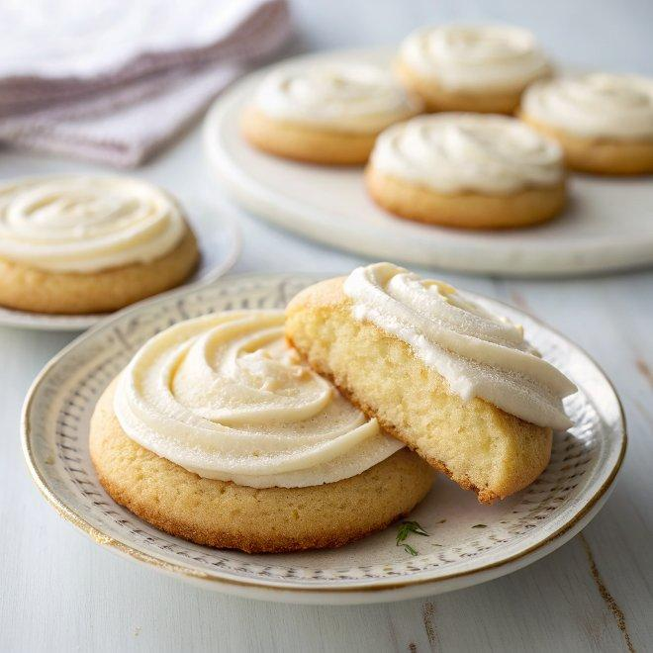

INGREDIENTS  - Cookies:  - 1 stick butter, softened  - 1 cup (240ml) sugar  - 2 eggs plus 1 yolk  - 1 tsp vanilla  - 1/2 tsp baking soda  - 1/2 tsp baking powder  - 3/4 cup sour cream  - 3 cups (720ml) flour, plus extra for rolling  - Frosting:  - 1/4 cup softened butter  - 1/4 cup Crisco (sub butter)  - 2 1/2 cups powdered sugar  - 2 tbsp hot water  - 2 tbsp heavy cream (sub milk)  - 1 tsp vanilla | PREP  COOK  1. For the cookies, cream together butter and sugar. Beat in eggs, sour cream, and vanilla. Add baking soda, baking powder, and flour. Mix until a soft dough forms. Cover and refrigerate for 4-6 hours.  2. Roll out dough 1/4-inch (10cm) thick on a floured surface. Cut into small circles (2 1/2 inches in diameter) and bake at 425°F (220°C)or 3-4 minutes. Wait until cookies are cool before frosting.  3. For the frosting, beat together all ingredients with an electric mixer until very smooth. Frosting will set lightly after a few hours.  PLATING

