TOMATO, BASIL & ARTICHOKE PICNIC SANDWICH  COOK TIME: 30 min  SOURCE:  #quick #healthy #sandwich | 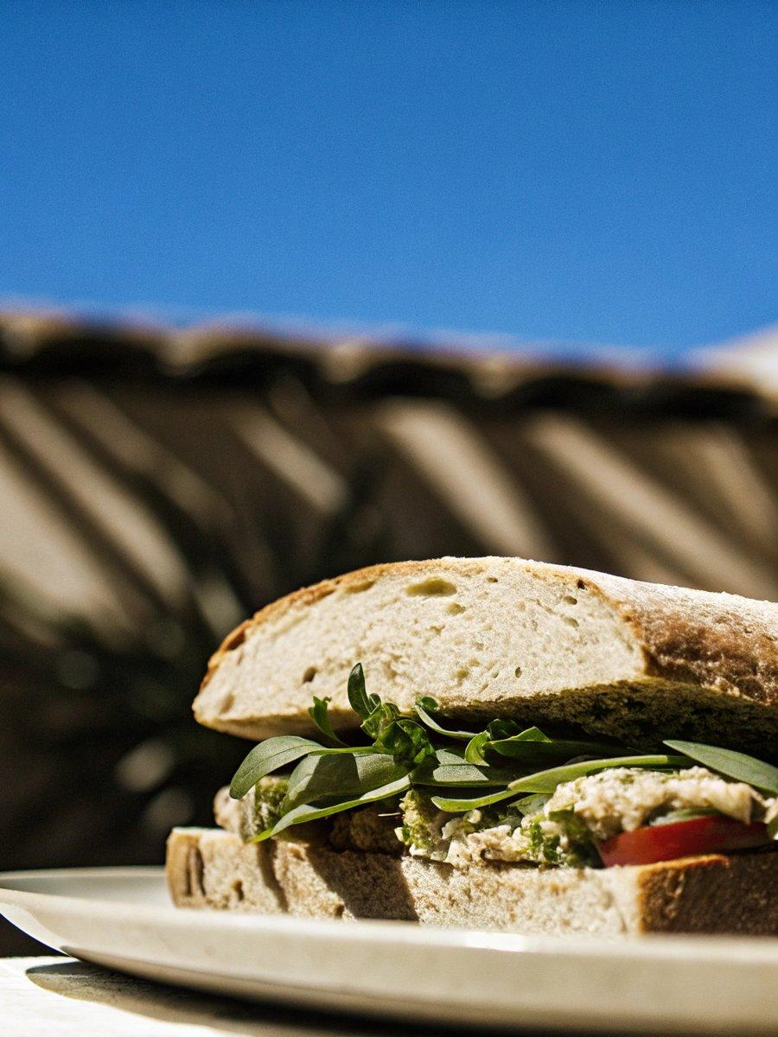

INGREDIENTS  - 1 1/2 cups edamame  - 1/4 cup basil  - 3 tbsp fresh lemon juice  - 1 tbsp chopped scallions  - 1/2 small garlic clove  - 2 tbsp olive oil  - 1 to 3 tbsp water  - 1/2 tsp sea salt, more to taste  - 1 large baguette  - handful of baby salad greens (or arugula)  - 2-3 medium tomatoes, sliced  - 10 basil leaves  - 10 jarred roasted artichokes, cut into quarters or roughly chopped  - pine nuts, optional | PREP  COOK  1. Make the basil-edamame spread: Place the edamame, basil, lemon juice, scallions, garlic, and sea salt into the bowl of a food processor. Pulse until chopped. Add the olive oil and blend until smooth. Add up to 3 tablespoons of water to create a smooth, spreadable consistency. Season to taste and chill until ready to use. The filling can be in advance and stored in the fridge for 3 to 4 days.  2. Slice one large baguette in half and assemble with the basil-edamame spread, greens, tomatoes, basil, artichokes and pine nuts. Close the baguette, wrap it in foil and place in the fridge until you're ready to divide into servings. Slice into 4 individual servings and either wrap them to go or enjoy!  PLATING

