CURRIED SALMON BURGER LETTUCE WRAPS W/CRISPY SWEET POTATO STRAWS + GOAT CHEESE.  COOK TIME: 40 min  SOURCE:  #healthy #quick #comfort-food | 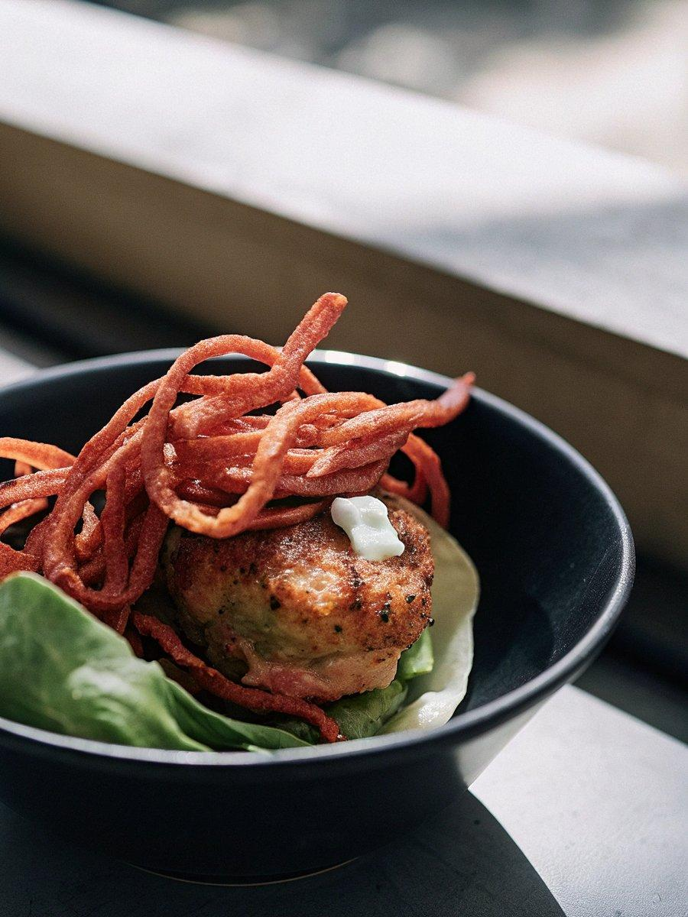

INGREDIENTS  - 2 medium sweet potatoes  - 3 tbsp coconut oil (melted)  - 1 tsp spicy curry powder  - salt and pepper (to taste)  - 1 lb wild caught salmon (skin removed)  - 1/3 cup Panko bread crumbs (use gluten free bread crumbs if needed)  - 2 tbsp parmesan  - 2 tbsp thai red curry paste  - 1/2 tbsp fish sauce  - 1 tsp fresh ginger (minced or grated)  - 1 clove garlic (minced or grated)  - 1 tbsp coconut oil  - 1 head butter lettuce  - 1/2 of a hot house cucumber (sliced)  - 1 small mango (skin removed + sliced)  - 1/4 cup cashews (chopped)  - 4 oz goat cheese (crumbled)  - 1 cup (240ml) plain greek yogurt  - 2 tbsp fresh mint (chopped)  - 1/2 tsp crushed red pepper flakes  - 1/2 lemon (juiced)  - pinch of salt and pepper | PREP  COOK  1. Preheat the oven to 375°F (190°C).  2. Slice the sweet potatoes into 1/8-inch (20cm) thick straws or use a mandolin slicer and do the same. Place the straws on a baking sheet and toss them with the melted coconut oil, curry powder, salt and pepper. Toss well. Divide the straws between two baking sheets. Bake for 15 minutes, toss, and then bake another 15-20 minutes more or until just beginning to crisp on the edges.  3. Meanwhile add the salmon to the bowl of a food processor and pulse until it’s somewhat ground. You can also chop the salmon very finely with a sharp knife.  4. Remove and add the chopped salmon to a bowl with the Panko bread crumbs, parmesan, thai red curry paste, fish sauce, ginger and garlic. Mix with a spoon until just combined. Form into 4 equally sized burgers. Heat a skillet (or grill) over medium-high heat with a tablespoon of coconut oil. Cook burgers on each side until golden, about 3-4 minutes per side.  5. In a bowl mix together the yogurt, mint, crushed red pepper, lemon juice and a pinch of salt and pepper. Mix and place in the fridge until ready to serve.  6. To assemble the wraps place a salmon patty on a leaf of lettuce. Add a dollop of the minted yogurt, a few slices of cucumber + mango. Top with the crispy sweet potato straws and a sprinkle of crumbled goat cheese.  PLATING

