WALNUT CAKE  COOK TIME: 45 min  SOURCE:  #sweet #baked #nutty | 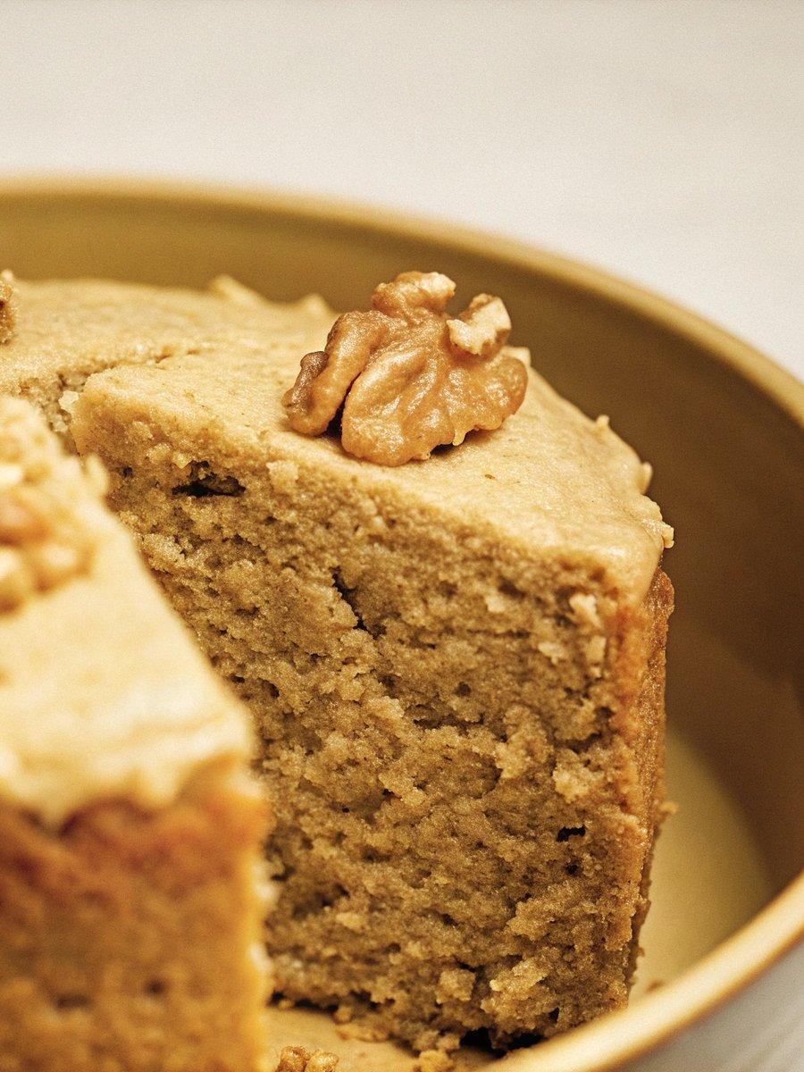

INGREDIENTS  - 4 oz. all-purpose flour  - 1 tsp baking powder  - 4.5 oz salted butter (room temperature)  - 1 tsp vanilla extract  - 3 oz fine sugar  - 2 large eggs  - 2 oz walnut (processed in a food processor until fine)  - 2 tbsp milk  - 1 oz whole walnut (for topping) | PREP  COOK  1. Preheat the oven to 350°F (180°C). Grease two mini loaf pans with butter. Sift the flour and baking powder, and set aside.  2. Cream the butter, vanilla extract, and sugar until fluffy and pale (this takes about 4 minutes using an electric hand mixer at speed 2). Add the eggs one at a time, creaming well after each addition before adding the next.  3. Fold in the flour, ground walnuts, and milk, mixing until well combined. Transfer the batter to the greased pan and gently shake it to level off. Sprinkle whole walnuts on top.  4. Bake for 30-35 minutes, or until a cake tester inserted into the walnut cake comes out clean. Remove from the oven and let cool on a wire rack. Loosen the cake from the loaf pans and slice it into pieces.  PLATING

