CAULIFLOWER RICE KIMCHI BOWLS  COOK TIME: 30 min  SOURCE:  #healthy #quick #comfort-food | 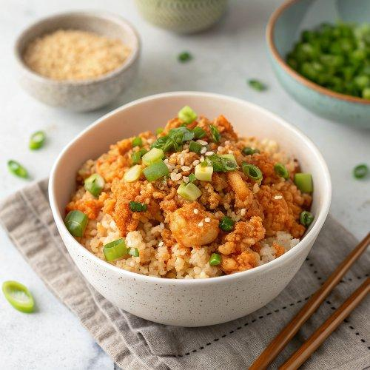

INGREDIENTS  - 1/3 cup coconut milk  - 2 tbsp white miso paste  - 1 tbsp rice vinegar or fresh lime juice  - 1 tsp minced ginger  - Pinch of sea salt  - 1 small head of cauliflower, riced  - 1/2 cup chopped scallions  - 1/2 garlic clove, minced  - 7 oz shiitake mushrooms, stemmed and sliced  - 1/2 tsp rice vinegar  - 1/2 tsp tamari  - 6 leaves curly kale, stemmed and torn  - 14 oz baked tofu  - 1 avocado, diced  - 1/2 cup kimchi (I used Mother in Law's kimchi)  - 1/4 cup microgreens, optional  - Sprinkle of sesame seeds, optional  - Extra-virgin olive oil, for drizzling  - Sea salt  - Lime slices, for serving | PREP  COOK  1. Make the coconut sauce: In a small bowl, whisk together the coconut milk, miso paste, lime juice or rice vinegar, ginger, and salt. Set aside.  2. In a large nonstick skillet, heat a drizzle of olive oil over low heat. Add the riced cauliflower, the scallions, garlic, and a few pinches of salt, and cook, stirring occasionally, for 3 minutes just to take the raw flavor off the cauliflower. Remove from the heat and stir in ½ of the coconut sauce. Portion the cauliflower rice into 4 bowls.  3. Wipe any remaining cauliflower bits out of the skillet. Heat the pan back to medium with a few splashes of olive oil. Add the mushrooms and a few pinches of salt and cook, stirring occasionally, until tender, about 5 minutes. Remove from the heat and stir in the rice vinegar and tamari. Add the mushrooms to the cauliflower bowls.  4. Wipe out the skillet again, add a tiny bit of water and the kale and cook over medium heat, covered, for 1 minute or until lightly wilted.  5. Finish assembling the bowls by drizzling more of the coconut sauce over each portion of cauliflower. Add the kale, tofu, avocado, and kimchi to the bowls along with the microgreens and sesame seeds, if using. Serve with any remaining sauce and the lime slices on the side.  PLATING

