HERBAL CHRYSANTHEMUM TEA (菊花茶)  COOK TIME: 1h  SOURCE:  #herbal #refreshing #healthy | 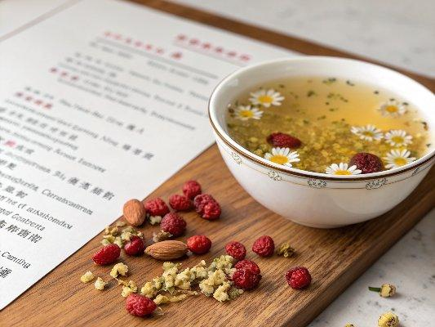

INGREDIENTS  - 1 pack Root + Spring Baby Chrysanthemum & Ginseng Herbal Tea Mix  - OR  - 2 cups (480ml) dried baby chrysanthemum Ju Hua  - 1/4 cup loosely packed goji berries Gou Ji Zi  - 1/4 cup loosely packed licorice root Gan Cao  - 2 tbsp loosely packed American ginseng Xi Yang Shen  - Optional 3 to 4 tbsp rock sugar (or 1 pack Root + Spring yellow rock sugar) | PREP  COOK  1. Place all the herbs in a colander and rinse under running water. Transfer to a medium-size pot and add 10 cups (2400ml) water.  2. (Optional) If you like sweet tea, add the rock sugar.  3. Heat over medium-high heat until the water is brought to a simmer. Turn to low heat. Cover and simmer for an hour. Do not uncover the pot during simmering.  4. When the tea is done, stir a few times to make sure the rock sugar is dissolved.  5. Place a strainer over a large bowl (or medium-size pot), pour the tea over and discard all the solid ingredients.  6. You can serve the tea hot. Alternatively, wait until the tea cools down to room temperature. Add ice cubes and serve the tea cold.  7. You can store the tea in an airtight container in the fridge for up to a week.  PLATING

