HOW TO MAKE BUTTERCREAM FLOWERS  COOK TIME: 15 min  SOURCE:  #decorative #sweet #baking | 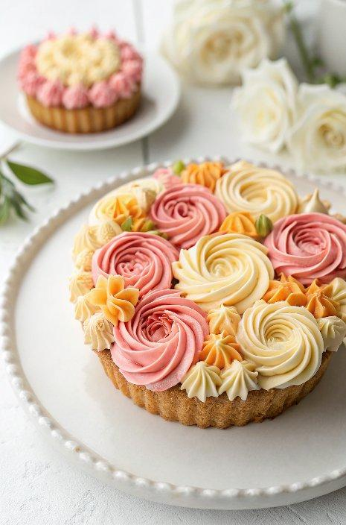

INGREDIENTS  - 1 cup (240ml) butter (225 g, unsalted, room temperature)  - 1.5 lb confectioners sugar ( 460 g, sifted)  - 1 tsp rose water  - Soft pink, yellow and orange food coloring  - 1 tbsp matcha powder | PREP  COOK  1. For the American Buttercream:  2. In a stand mixer fitted with a paddle attachment, cream the room temperature butter until smooth.  3. Sift in the confectioner’s sugar. You can add the sugar in two batches.  4. Beat until you get to a thick consistency. Add a few drops of rose water.  5. Save a small amount of buttercream in a bowl. Add more confectioners sugar and mix by hand until you get a play dough consistency. This will be used for the base of your flowers.  6. Separate and dye a few batches yellow, blush and darker pink. Use some matcha powder to dye some buttercream a natural green for the leaves.  7. Transfer the green to a bag fitted with a 68 tip.  8. For the Assembly:  9. Cut 2.5-inch (13cm) squares of parchment paper.  1  0. Transfer the yellow buttercream to piping bag. Snip off the tip.  1  1. Add the 127 tip to a piping bag. Transfer the blush and darker pink buttercreams to one bag. Work out the air bubbles and give it a test.  1  2. Use a dash of buttercream to glue down the square of parchment paper to a piping nail or turntable.  1  3. Mold a small cone of the thick base buttercream in the middle of the square.  1  4. Add bits of yellow in the middle.  1  5. Pipe a spiral, then add arcs to the spiral, curving up. Add more petals until you’ve reached a desired rose look.  1  6. For a peony or closed rose, start off with a smaller base, pipe tight arcs and close off in a round shape.  1  7. When you’re ready to use the roses, cut the bottom with scissors and transfer to your cake, cupcake or cookie.  1  8. Pipe leaves with the green buttercream to create some dimension.  PLATING

