TACO SALAD DIP RECIPE  COOK TIME: 10 min  SOURCE:  #quick #comfort-food #party-food | 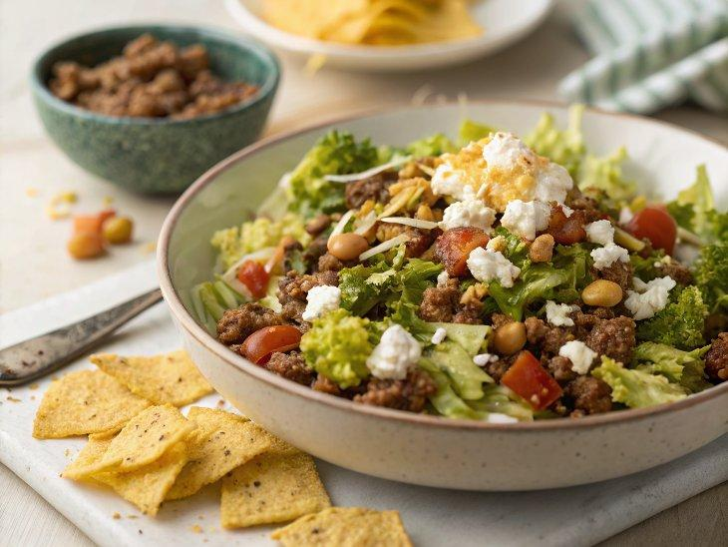

INGREDIENTS  - 1 package Taco Seasoning Mix (we bought Original Taco by McCormick)  - 1/4 cup water  - 1 lb lean ground beef (I purchased 7% fat)  - 1 8 oz package cream cheese  - 1 cup (240ml) cottage cheese (any size curd)  - 1 cup (240ml) salsa (we used our roasted salsa, but you can use any salsa)  - 2 cups (480ml) 8 oz finely shredded medium cheddar cheese  - 2 cups (480ml) shredded lettuce  - 2 cups (480ml) finely chopped tomatoes  - 1 avocado (diced, optional)  - Cilantro for garnish (optional)  - Taco Chips (or any kind of firm tortillas to serve) | PREP  COOK  1. In a large skillet, brown ground beef (No need to add oil). Drain with a paper-towel if there is excess liquid. My lean 7% beef didn't have any extra juices to drain.  2. Combine 1 packet of taco seasoning mix with 1/4 cup water. Once the beef is fully cooked, stir the taco seasoning mix into the beef and remove from heat to cool down.  3. In the bowl of a food processor, blend 1 cup (240ml) cottage cheese, 1 package cream cheese and 1 cup (240ml) salsa until well combined and smooth.  4. Spread beef into the bottom of a 9x13-inch (23x33cm) glass baking pan, or into individual glass ramekins. Top the meat with the blended cream cheese mixture.  5. Sprinkle evenly with finely grated cheese. Top with sliced lettuce, diced tomatoes, avocado and cilantro (if using). If you aren't serving right away, you might squeeze some lime juice over your avocado to keep it from browning, then cover with plastic wrap and refrigerate until ready to serve. Serve with Taco chips; naturally.  PLATING

