ITALIAN SEASONING  COOK TIME: 1 min  SOURCE:  #quick #flavorful #herb-blend | 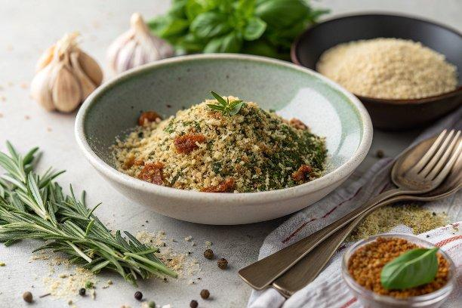

INGREDIENTS  - 2 tbsp dried basil  - 2 tbsp dried oregano  - 1 tsp garlic powder  - 2 tsp dried rosemary  - 2 tbsp dried parsley  - 1 tbsp dried thyme  - 1 tbsp dried marjoram | PREP  COOK  1. Place all of the ingredients in a small bowl. Stir until well combined.  2. Use immediately, or transfer to an airtight container and store in a cool, dry place for up to 6 months.  PLATING

