BALSAMIC VINEGAR REDUCTION  COOK TIME: 15 min  SOURCE:  #quick #condiment #flavor-enhancer | 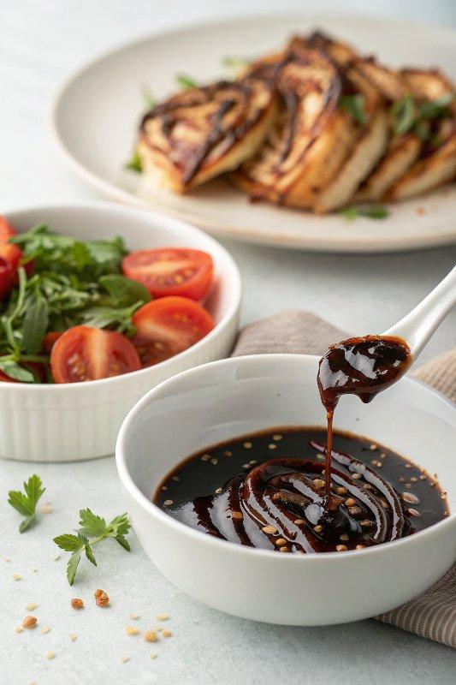

INGREDIENTS  - 1 cup (240ml) balsamic vinegar  - 1 Tbsp granulated sugar | PREP  COOK  1. In a small saucepan, combine the balsamic vinegar, and sugar if using, and bring to a boil over high heat. When it starts to boil, reduce the temperature to maintain a simmer.  2. Cook the vinegar down, stirring occasionally until it's about a third of the original volume, which should take about 13 - 15 minutes.  3. Allow the reduction to cool completely before transferring to a glass jar. The reduction will continue to thicken as it cools. Enjoy!  PLATING

