SERIOUSLY GOOD 7 LAYER DIP  COOK TIME: 1h  SOURCE:  #party-food #dips #comfort-food | 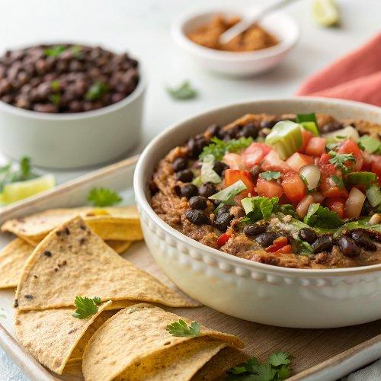

INGREDIENTS  - 2 cups (480ml) dry black beans, about 12 oz (340 g)  - 8 cloves garlic, smashed and peeled  - Half an onion, roughly chopped  - 2 tsp ground cumin  - 1 tbsp chili powder  - 1 1/2 tbsp dried oregano  - 1 1/2 tsp smoked paprika  - 2 bay leaves  - 4 cups (960ml) low-sodium chicken broth (950 ml)  - 1 tsp fine sea salt, plus more as needed  - 1 batch black bean puree  - 4 large avocados  - Juice of half a lime  - 1/4 cup fresh cilantro leaves, finely chopped  - 16 oz sour cream, 2 cup (480ml)s (450 g)  - 3/4 tsp fine sea salt, for the avocado and sour cream ( 1/2 tsp for avocado and 1/4 tsp for sour cream)  - 1 tsp chili powder  - 1/4 tsp ground cumin  - 16 oz thick salsa, 2 cup (480ml)s (450 g)  - 8 oz queso fresco or cojita cheese, crumbled (226 g)  - 2 green onions, finely sliced  - 1 (2.25 oz) can sliced black olives, drained  - Tortilla chips, for serving | PREP  COOK  1. Cook the Black Beans  2. Stovetop Method: Add all black bean puree ingredients to a large saucepan or Dutch oven. If the liquid doesn’t cover the beans by about ½ an inch, add a bit of water. Bring to a boil over medium-high heat, then reduce to a low simmer. Cook, partially covered with a lid, for 1 ½ to 2 hours, or until the beans are tender, adding more water if the mixture gets too dry. Test 4 to 5 of the beans by pressing them against the side of the pot with a fork. They should be easy to press. If not, continue to simmer until the beans are tender.  3. Instant Pot Method: Add all black bean puree ingredients to a 6-quart Instant Pot. Secure the lid, then pressure cook on high for 45 minutes. Allow the pressure to naturally release. Carefully open the lid. Test 4 to 5 of the beans by pressing them against the side of the pot with a fork. They should be easy to press. If not, use the sauté setting and simmer the beans until tender.  4. Make the Black Bean Puree  5. Blend the beans: Remove the bay leaves, then use an immersion blender to puree the beans until completely smooth. Taste the puree, then adjust with salt as needed. I season generously because it acts as the base of the dip.  6. Assemble the 7 Layer Dip  7. Layer 1: Spread the black bean puree evenly on the bottom of a 9×13-inch (33cm) serving dish.  8. Layer 2: In a medium bowl, mash the avocados with the lime juice, ½ teaspoon of the salt, and the cilantro. Spread this mixture evenly over the bean puree.  9. Layer 3: In a separate bowl, stir together the sour cream, 1 teaspoon chili powder, the remaining ¼ teaspoon of salt, and the ground cumin. Carefully spread this mixture over the avocado layer to prevent browning.  1  0. Layer 4: Strain the salsa in a fine mesh strainer to remove excess liquid, then spread it evenly over the sour cream.  1  1. Layer 5: Sprinkle the crumbled cheese evenly over the salsa.  1  2. Layer 6: Scatter the sliced green onions over the cheese.  1  3. Layer 7: Top the dip with the drained black olives.  1  4. Serving: Serve the dip immediately with tortilla chips, or cover and refrigerate until you’re ready to serve.  PLATING

