VEGAN DUMPLINGS WITH SPICY DIPPING SAUCE  COOK TIME: 15 min  SOURCE:  #dumplings #spicy #comfort-food | 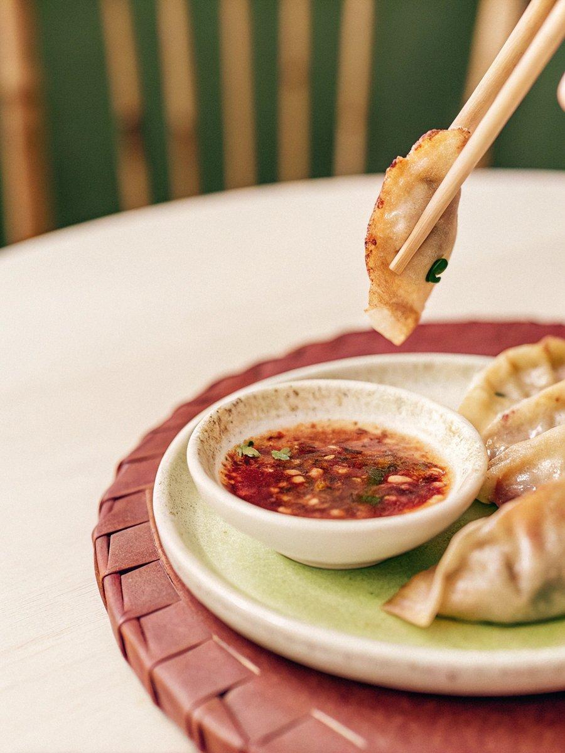

INGREDIENTS  - 250 g all-purpose flour (about 2 cups, plus some for dusting)  - 130 ml water (1/2 cup+2 tsp (see note 1)  - 150 g five-spice tofu/smoked tofu (finely chopped, about 1 cup)  - 70 g Chinese chives (finely chopped, about 1 cup)  - 6 shiitake mushrooms (finely chopped, about 1/3 cup (see note 2)  - 50 g carrot (grated, about 1/2 cup)  - 1 tbsp scallions (finely chopped)  - 1/2 tsp ginger (minced)  - 1/4 tsp ground Sichuan pepper  - 1 tbsp cooking oil  - 2 tsp light soy sauce  - 1/4 tsp sesame oil  - 1/4 tsp salt (or to taste)  - cooking oil  - water  - 1 tbsp cooking oil  - 1 tsp chilli flakes  - 1/4 tsp ground Sichuan pepper  - 1 tsp scallions (finely chopped )  - 1 pinch sugar  - 2 tsp light soy sauce  - 2 tsp black rice vinegar | PREP  COOK  1. Make the dough  2. In a mixing bowl, add water to the flour gradually. Mix with chopsticks/spatula until no more loose flour can be seen. Combine and knead into a dough.  3. Leave to rest (covered) for 10-15 minutes then knead again until smooth (see note 3).  4. Cover and rest for a further 30-60 minutes until it becomes soft.  5. Prepare the filling  6. Put tofu, Chinese chive, mushroom and carrot into a large bowl. Place scallions, ginger and ground Sichuan pepper on top.  7. Heat the oil until smoke appears. Pour it over scallions, ginger and Sichuan pepper.  8. Add light soy sauce, sesame oil and salt. Mix well.  9. Roll the wrappers  1  0. Divide the dough into three parts.  1  1. Roll one part into a rope then cut into 10 equal sections (cover the rest to prevent them from drying out).  1  2. Press each piece into a small disc with the palm of your hand.  1  3. Use a rolling pin to flatten it into a thin disc. Dust with flour if it sticks.  1  4. Assemble the dumplings  1  5. Place a spoonful of filling on the wrapper.  1  6. Fold and seal the middle part.  1  7. Make 2-4 pleats from each end.  1  8. Press all around the edge to seal completely.  1  9. Fry the dumplings  2  0. Coat a frying pan with a thin layer of oil. Heat up over high heat. Place the dumplings in the pan.  2  1. When the bottom part becomes golden brown, pour in water (enough to cover 1/3 of the dumplings) then cover with a lid.  2  2. Uncover when the water evaporates completely. Cook another 30 seconds to crisp up.  2  3. Prepare the sauce  2  4. Heat the oil until smoke appears. Put chilli flakes, ground Sichuan pepper, scallion and sugar into a bowl. Pour hot oil over.  2  5. Add light soy sauce, black rice vinegar. Mix well.  2  6. Make-ahead tips  2  7. Right after the dumplings are assembled, lay them on a tray to freeze (dust with flour or line with parchment paper). Then put them in an air-tight bag when frozen.  2  8. Whenever you need to cook them, pan fry the usual way without defrosting.  PLATING

