BLUEBERRY SYRUP  COOK TIME: 10 min  SOURCE:  #quick #sweet #breakfast | 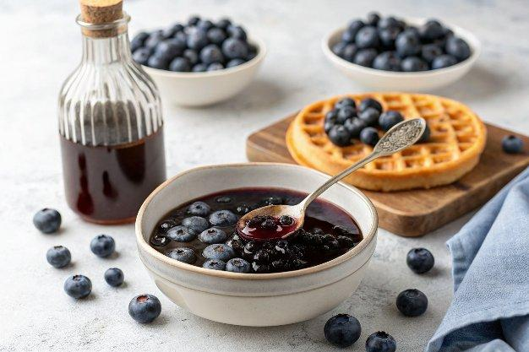

INGREDIENTS  - 2 cup (480ml)s (10 oz) blueberries  - 1 cup (240ml) + 2 Tbsp blueberry juice, (grape juice or apple juice, divided)  - 1/3 cup granulated sugar*  - 4 tsp cornstarch  - 1 Tbsp lemon juice | PREP  COOK  1. Add blueberries, 1 cup (240ml) juice and sugar to a small saucepan, stir. Bring to a simmer over medium-high heat.  2. Reduce heat to low and let simmer 6 - 10 minutes, stirring occasionally, until many of the blueberries have burst.  3. In a small bowl whisk together remaining 2 Tbsp juice with the cornstarch then pour into pan. Let simmer 1 minute longer to thicken while stirring constantly.  4. Remove from heat. Stir in lemon juice.  5. If desired press and strain through a mesh sieve to remove skins, blitz in a blender (be sure to remove lids center insert and cover with a towel to blend since it's a hot liquid), or serve as is.  PLATING

