HOT HONEY CHICKEN MEATBALLS  COOK TIME: 20 min  SOURCE:  #quick #comfort-food #meatballs | 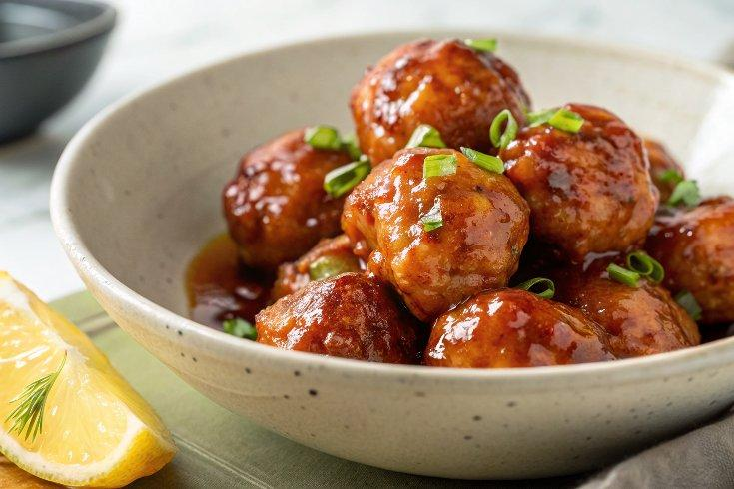

INGREDIENTS  - 1 lb (450 g) ground chicken, see notes if you have 1 1/4 lb package  - 1/2 cup (35 g) panko breadcrumbs or homemade breadcrumbs  - 1/3 cup milk, dairy or non-dairy  - 1 large egg  - 1/4 cup Parmigiano-Reggiano cheese, finely grated, 1/2 oz  - 1/2 tsp garlic powder  - 1/2 tsp onion powder  - 1/2 tsp sweet paprika  - 1/4 tsp smoked paprika  - 1/2 tsp dried oregano  - 1/2 tsp fresh ground black pepper  - 3/4 tsp fine sea salt  - 2 tbsp high-heat cooking oil like grape seed or avocado oil  - 2 tbsp unsalted butter  - 1 tbsp honey  - 1 tbsp hot sauce, or more to taste, we like Crystal or Tabasco  - Pinch of salt | PREP  COOK  1. Stir breadcrumbs and milk in a large bowl, then let it sit for 5 minutes. Add the egg, cheese, garlic powder, onion powder, sweet paprika, smoked paprika, oregano, pepper, and salt. Stir until well blended.  2. Add the ground chicken, and use a fork or your fingers to gently mix everything until combined. Try not to overmix for the most tender meatballs.  3. Wet your hands and form the mixture into 1 ½-inch balls (about 1 ½ tablespoons each). A medium cookie scoop helps portion out the meatballs. The mixture is on the softer side, so don’t worry if you have difficulty making perfect balls. Since we want tender and juicy meatballs, we add more bread crumbs and milk, making the mixture less firm. Even though this causes less-than-perfect round meatballs, the texture of the interior is better.  4. Heat 2 tablespoons of oil in the bottom of a wide Dutch oven or nonstick pan over medium heat.  5. Place the meatballs in the hot oil and cook until they are cooked through, the outsides are browned, and they register 165°F (75°C) in the middle on an instant-read thermometer, about 15 minutes. Depending on the shape or size of the pot, this might need to be done in two batches.  6. Make the hot honey butter. Combine the hot sauce, butter, salt, and honey in a small saucepan over medium-low heat. Swirl the pan until the butter melts into the hot sauce and honey.  7. Pour the sauce over the cooked meatballs, and then serve.  PLATING

