BLACK SESAME DAN DAN NOODLES  COOK TIME: 30 min  SOURCE:  #quick #comfort-food #noodles | 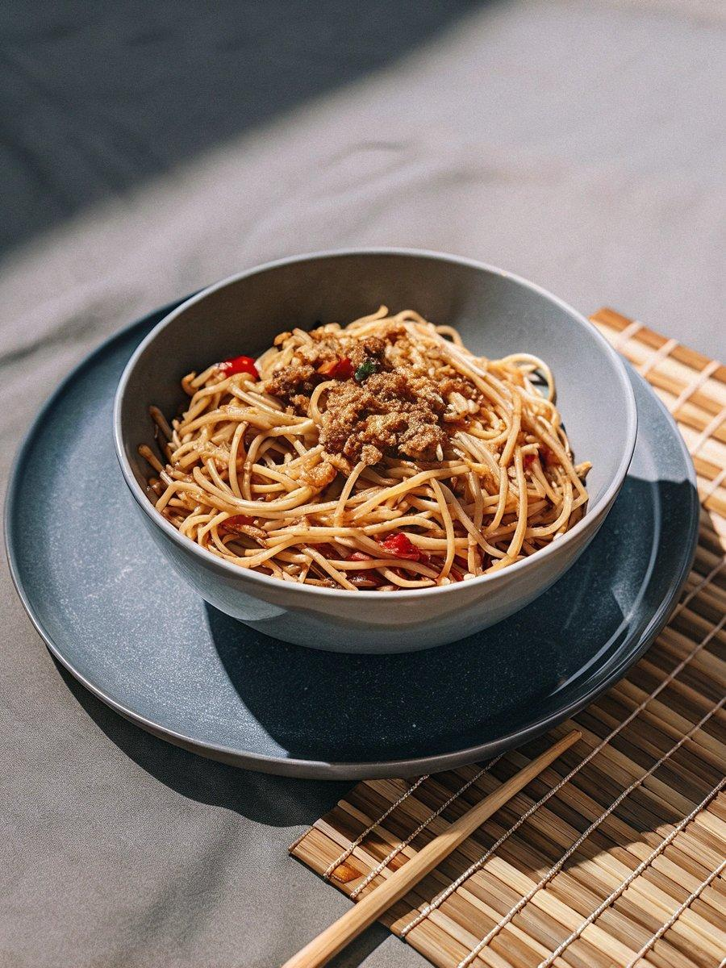

INGREDIENTS  - 1/2 cup soy milk  - 1 1/2 Tbsp black sesame paste (you can make homemade Black Sesame Paste; see Notes for substitutions)  - 2 cups (480ml) chicken stock/broth  - 1 Tbsp rice vinegar (unseasoned)  - 1 Tbsp soy sauce  - 1 tsp sugar  - 1/2 tsp Diamond Crystal kosher salt (adjust the amount based on your chicken stock’s saltiness)  - 1 clove garlic  - 1 tsp ginger (grated, with juice; from a 1-inch, 2.5-cm knob)  - 1 Tbsp toasted sesame oil  - 6 oz ground pork  - 1 tsp sake  - 1/4 tsp freshly ground black pepper  - 2 tsp tianmianjiang (sweet bean sauce) (or use miso)  - 1 tsp doubanjiang (spicy chili bean paste) (use either the spicy or non-spicy type, or use gluten-free doubanjiang); see Notes)  - 1 tsp soy sauce  - 1 tsp sugar  - 1 Tbsp peanuts (roasted; or use walnuts)  - 1 Tbsp toasted black sesame seeds  - 1 head Shanghai bok choy  - 4 green onions/scallions  - 2 oz bean sprouts ( 1/2 cup, 1 handful) 1/2 1  - 12 oz dan dan noodles  - 2 Tbsp fried garlic chips (or more; you can make homemade Garlic Chips)  - 4 tsp la-yu (Japanese chili oil) (or plus more; store bought or make my Homemade La-yu) | PREP  COOK  1. Gather all the ingredients.  2. To Make the Soup Broth  3. Combine ½ cup soy milk and 1½ Tbsp black sesame paste. Using your silicone spatula, press the black sesame paste against the liquid measuring cup (or bowl) to dissolve the paste.  4. Once the paste is dissolved, transfer to the pot and heat up the soup. Add 2 cups (480ml) chicken stock/broth. NOTE: We like a creamier soup, but if you prefer a thinner soup, add more chicken stock.  5. Add 1 Tbsp rice vinegar (unseasoned), 1 Tbsp soy sauce, and 1 tsp sugar. Increase the amount if you added more chicken stock.  6. Mix well and taste the soup. Adjust the amount of kosher salt based on your chicken stock. I added ½ tsp Diamond Crystal kosher salt.  7. If you want to have COLD black sesame dan dan noodles, remove the soup from the heat and chill the soup in iced water. Then, refrigerate it until the rest of the ingredients are ready. You can keep it in the refrigerator up to 24 hours. Here, I took half of the soup to chill (for me) and keep the hot soup for Mr. JOC.  8. To Make the Meat Sauce  9. Grate 1 clove garlic. Grate knob of ginger and measure about 1 tsp ginger (grated, with juice). You don’t have to grate the entire ginger.  1  0. Heat 1 Tbsp toasted sesame oil over medium heat and cook the grated garlic and ginger until fragrant. Be careful not to burn them.  1  1. Add 6 oz ground pork and continue to stir with a spatula and separate the meat.  1  2. Add 1 tsp sake and ¼ tsp freshly ground black pepper.  1  3. Add 2 tsp tianmianjiang (sweet bean sauce) and 1 tsp doubanjiang (spicy chili bean paste).  1  4. Add 1 tsp soy sauce and 1 tsp sugar.  1  5. Stir and coat the meat with the sauce.  1  6. To Prepare the Toppings  1  7. Grind 1 Tbsp peanuts with a amortar and pestle; you could also put the peanuts in a plastic bag and crush them using a rolling pin.  1  8. Grind 1 Tbsp toasted black sesame seeds.  1  9. Cut 1 head Shanghai bok choy into quarters lengthwise.  2  0. Cut 4 green onions/scallions in half separating the green and white parts. Cut the white part in half lengthwise and keep the green part for later.  2  1. Cut the white part into julienned strips. Then, soak in iced water for 15 minutes to remove the bitterness and to make it crisp. Drain well and set aside.  2  2. Chop the green part of the green onion into fine rounds.  2  3. Bring a pot of water to a boil. Once boiling, add the bok choy first to blanch for 2–3 minutes (depending on its size). Then, add 2 oz bean sprouts. Cook for 10 seconds and remove both the bok choy and bean sprouts from the water to drain completely.  2  4. To Assemble  2  5. Cook 12 oz dan dan noodles according to the package instructions. I recommend cooking 15–20 seconds less than what package says, as the remaining heat will continue to cook the noodles.  2  6. To make COLD dan dan noodles: Soak the noodles in iced water until chilled and drain completely. Transfer the noodles to a large bowl and pour in the chilled black sesame soup.  2  7. Place the bok choy, bean sprouts, and meat sauce on top of the noodles.  2  8. Garnish with peanuts, black sesame seeds, the white and green parts of the green onion, and 1 Tbsp garlic chips, and drizzle with 2 tsp la-yu (Japanese chili oil). The COLD dan dan noodle is ready to serve.  2  9. To make HOT dan dan noodles: Serve the hot noodles in a large bowl and pour in the hot black sesame soup. Place the bok choy, bean sprouts, and meat sauce on top of the noodles.  3  0. Garnish with peanuts, black sesame seeds, the white part of the green onion, and 1 Tbsp garlic chips, and drizzle with 2 tsp la-yu (Japanese chili oil). Enjoy!  PLATING

