GOLDEN HASSELBACK SALMON  COOK TIME: 42 min  SOURCE:  #healthy #grilled #sustainable | 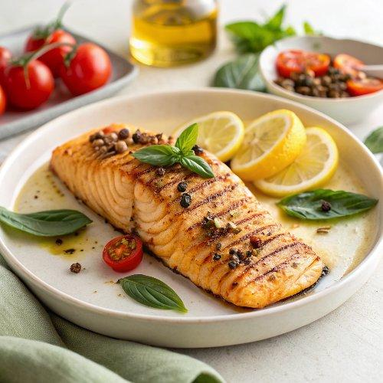

INGREDIENTS  - 1 x 1 kg side of salmon, skin on, scaled, pin-boned, from sustainable sources  - 1 lemon  - 1 bunch of basil (30 g)  - 1 x 50 g tin of anchovy fillets in oil, from sustainable sources  - 500 g ripe tomatoes, on the vine  - 2 tbsp harissa paste  - red wine vinegar  - 300 g wholewheat couscous  - 1 x 700 g jar of queen chickpeas  - 1 kg frozen mixed Mediterranean veg  - 100 g natural yoghurt | PREP  COOK  1. Preheat the oven to 220ºC/425°F (220°C)/gas  7. Use a sharp knife to score through the salmon flesh at 1cm (0-inch) intervals, slicing most of the way through towards the skin.  2. Finely grate the lemon zest on to a board. Pick over most of the basil leaves, reserving some nice ones in a bowl of cold water, and place the stalks in a blender. Add the anchovies to the board with a drizzle of oil from their tin and a pinch of sea salt and black pepper, finely chop together, then rub into all the cuts in the salmon.  3. Add the tomatoes, 1 tablespoon of harissa and 2 tablespoons of red wine vinegar to the blender. Blitz until smooth, season to perfection, then pour into a deep 30cm (12-inch) x 40cm (16-inch) roasting tray and stir in the couscous and chickpeas, juice and all. Sit the prepped salmon on top in the centre, then scatter the frozen veg around it. Cook on the top shelf of the oven for 30 minutes, or until golden and cooked through.  4. Sprinkle over the reserved basil leaves. Use fish slices to move the salmon to a board and portion up, then mix everything left in the tray. Mix the remaining harissa into the yoghurt. Serve with lemon wedges.  PLATING

