ELOTE (MEXICAN STREET CORN)  COOK TIME: 20 min  SOURCE:  #grilled #street-food #comfort-food | 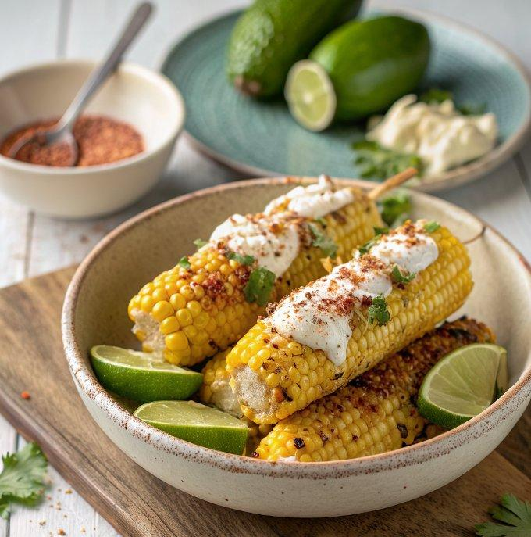

INGREDIENTS  - 4 ears of grilled corn on the cob  - 1/4 cup mayonnaise  - 1 1/2 tsp lime juice  - 1/2 tsp chili powder, plus more for sprinkling  - Pinch of cayenne pepper (optional, for extra heat)  - 1/4 tsp kosher salt or a pinch of fine salt  - 2 oz (about 1/2 cup) finely grated Cotija cheese*  - 2 tbsp finely chopped cilantro | PREP  COOK  1. While you’re grilling your corn, prepare the chili-mayo sauce and Cotija-cilantro blend. In a small bowl, combine the mayonnaise, lime juice, chili powder, optional cayenne, and salt. Stir until combined. In a separate bowl, mix together the cheese and cilantro. Set both bowls aside.  2. When your corn is ready to go, brush the mayonnaise mixture all over one ear of corn. Over a plate, sprinkle the Cotjia mixture liberally all over, turning the corn as necessary (it’s going to be a little messy, no way around it!). Place the finished cob on a separate serving plate. Repeat for the remaining corn, using the cheese in the bowl and the excess on the plate as needed.  3. Sprinkle a pinch or two of additional chili powder lightly over the corn. Serve warm.  PLATING

