THE ABSOLUTE EASIEST SPINACH AND ARTICHOKE PIZZA  COOK TIME: 15 min  SOURCE:  #quick #comfort-food #pizza | 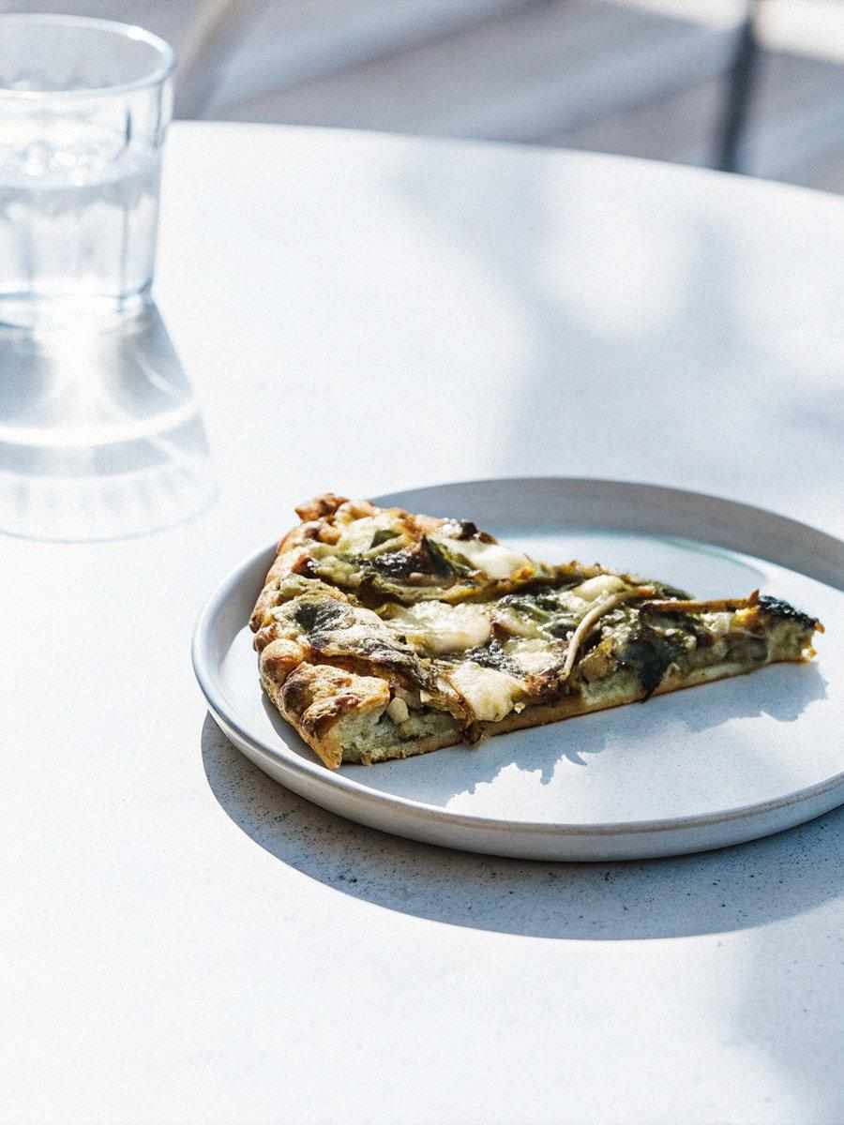

INGREDIENTS  - one 12-inch (30cm) pre-made pizza crust  - 3 oz garlic herb spreadable cheese (I used half of a package of Alouette)  - a few jarred or canned artichokes (I used a jar of grilled marinated artichokes)  - a handful of fresh baby spinach  - a handful of shredded mozzarella cheese  - some jarred sun-dried tomatoes, sun-dried tomato pesto, or similar | PREP  COOK  1. Preheat oven to 450 degrees. Layer your crust with the spreadable cheese. Add some artichokes, spinach, a few sun-dried tomatoes or small dollops of sun-dried tomato pesto. Top with cheese.  2. Bake for 10 minutes. Broil for the last 3-4 minutes to get it really nice and browned. Top with Parmesan if you are into that kinda thing. Boom! So good.  PLATING

