SINGAPORE MEI FUN (SINGAPORE RICE NOODLES, 星洲米粉)  COOK TIME: 8 min  SOURCE:  #quick #comfort-food #stir-fry | 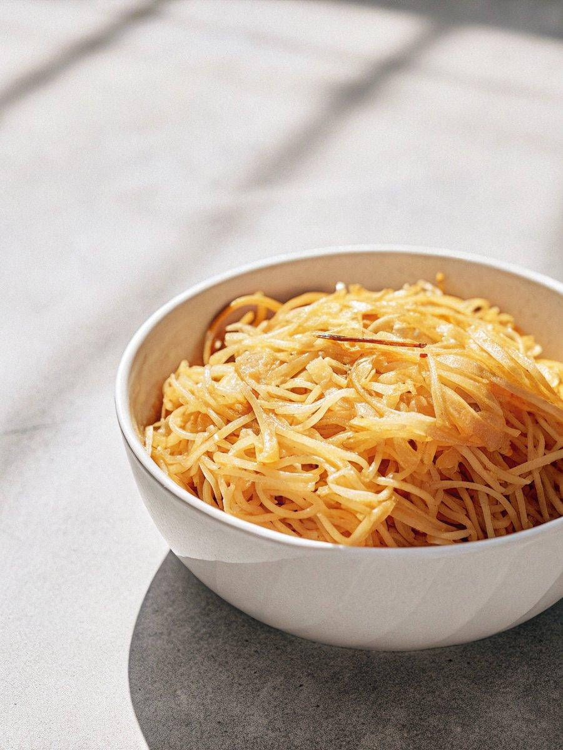

INGREDIENTS  - 90 g dried rice vermicelli (Mei Fun) (see note 1)  - 1/2 tbsp light soy sauce  - 1/2 tbsp oyster sauce  - 1/2 tbsp Shaoxing rice wine (optional)  - 1/2 tsp sesame oil  - 1/4 tsp salt (or to taste)  - 1/2 tsp sugar  - 1/2 lime, use the juice only  - 1 tbsp water  - 2 tbsp neutral cooking oil, divided  - 2 eggs, lightly beaten  - 8 shrimps, peeled and deveined  - 50 g Char Siu (Chinese BBQ pork) (see note 2 for substitutes)  - 2 cloves garlic, minced  - 1 tbsp yellow curry powder (see note 3)  - 100 g mung bean sprouts  - 60 g bell pepper, julienned  - 60 g red onion, sliced  - 1 stalk scallions, julienned | PREP  COOK  1. Prepare the vermicelli  2. You can either follow the instructions on the package to prepare the rice vermicelli or use my method: Put them into a large bowl. Pour in hot water (just boiled) enough to cover. Leave to soak for 2 mins.  3. Drain well then cut into shorter sections with a pair of scissors. Set aside (see note 1).  4. Mix the sauce  5. In a small bowl, mix light soy sauce, oyster sauce, Shaoxing rice wine, seame oil, salt, sugar, lime juice and water. Set aside.  6. Fry the eggs & shrimp  7. Heat up half of the cooking oil in a wok until it smokes. Pour in the egg. Fry until cooked then break it into small pieces with a spatula. Transfer to a plate.  8. In the same wok, sear the shrimp (no need to pour in more oil). As soon as they curl up and turn pink, transfer to the egg plate.  9. Stir-fry to finish  1  0. Pour the other half of the cooking oil into the wok. Fry garlic and yellow curry powder over low heat for 20 seconds or so (Do not burn).  1  1. Stir in the vermicelli. With the aid of a pair of chopsticks, loosen the vermicelli to have it evenly coated by the curry.  1  2. Turn the heat to medium high. Add Char Siu, mung bean sprouts, bell pepper & red onion. Constantly stir (I use chopsticks and a spatula at the same time) to evenly heat all the ingredients until the vegetables are cooked but still retain some of the crunchiness.  1  3. Put the egg and shrimp back into the wok. Add the sauce and scallions. Give everything a quick stir then serve immediately.  PLATING

